Name: ________________________________________ February 7, 2018

Kobrin/Losquadro Math 8

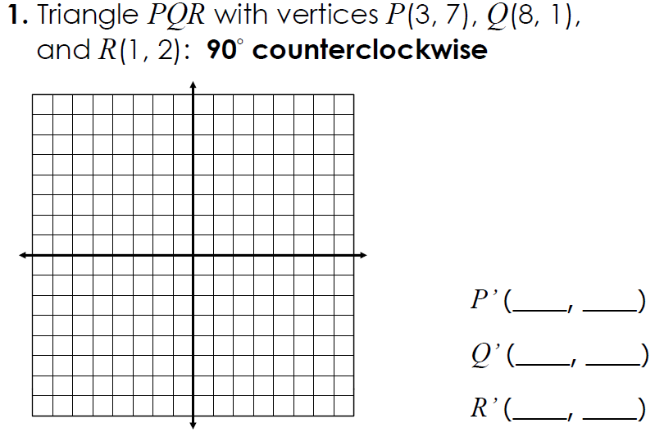**Rotations – Day 1**

