Name: ___________________________________________ February 6, 2018
Kobrin/Losquadro Math 8

Reflections – Day 2
Graph and label each figure and its image under a reflection in the given axis. Give the coordinates of the image.
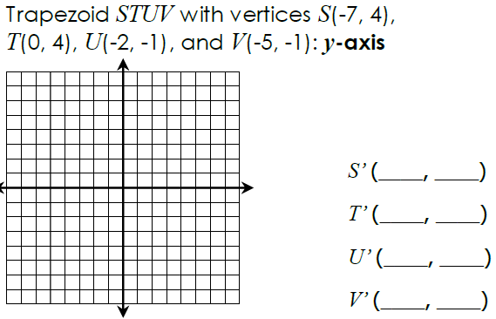

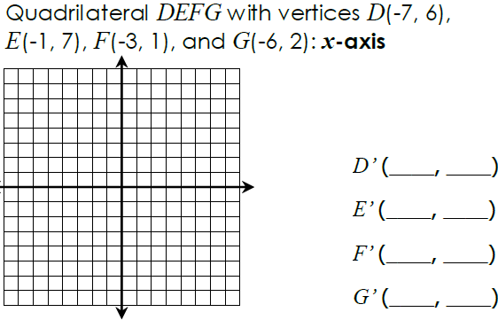

The coordinates of a point and its image are given. Name the line of reflection.

- S (3, -3) → S’(-3, -3)

- P (-4, -6) → S’(-4, 6)

- N (-5, 2) → N’_-5, -2)

- H (1, 7) → H’(-1, 7)

The coordinates of a point is given and the line of reflection. Name the image point.

- (-4, 2) x – axis

- (6, 2) y – axis

- (-5, -4) y- axis

- (9, -12) x – axis

