Name: _________________________________________ February 5, 2018

Kobrin/Losquadro Math 8

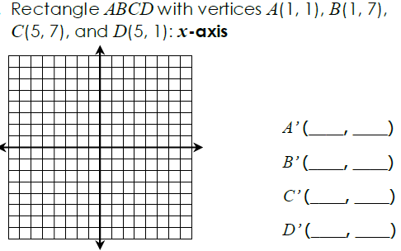**Line Reflections – Day 1**

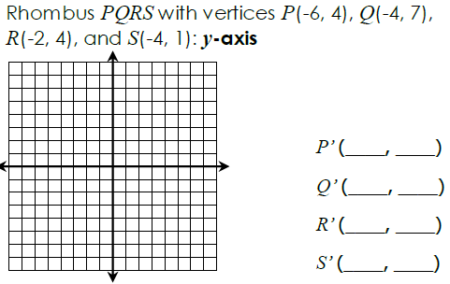1)

2)

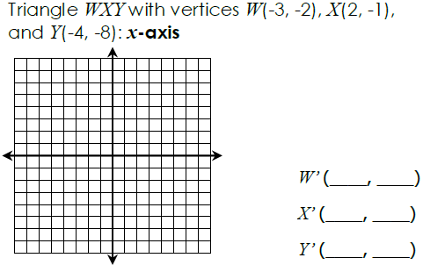3.

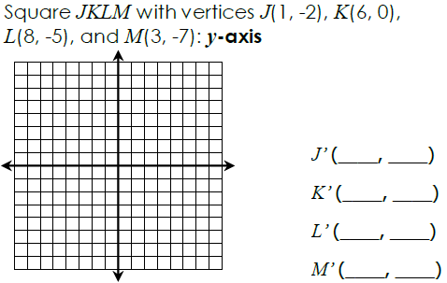4.