Name: __________________________________________ February 2, 2018
Kobrin/Losquadro Math 8
Translations Day 3
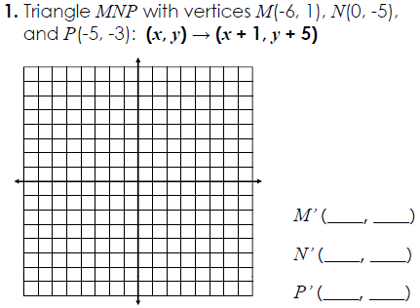
Graph and label each figure and its image under the given translation. Then, give the new coordinates

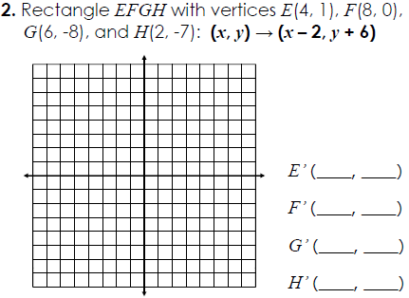

Write a rule describing each translation. First in words and then in coordinate notation
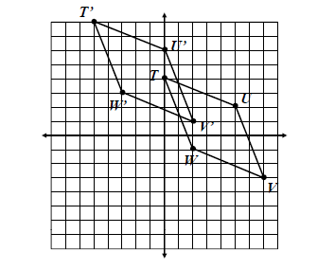
3.
Words

Coordinate Notation

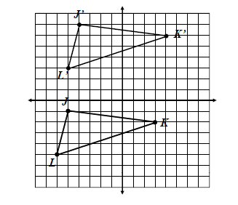
4.
Words

Coordinate Notation

Describe the translation using coordinate notation
5. A(5, 3) →A’(-4, -1) 6. C(-2, 1) → C’(5, 3)

