Name: _________________________ CC Algebra
January 27, 2017

Recursive Sequences

1) A geometric sequence is shown in the table below, where a_{n} represents the n^{th} term of the sequence. What is the recursive formula for the geometric sequence?
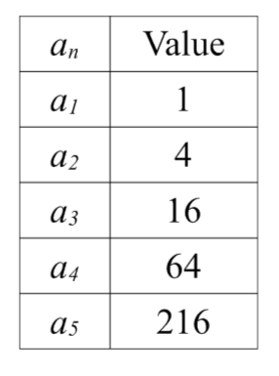
a) a_{n + 1} = a_{n}²
b) a_{n + 1} = a_{n} + 3
c) a_{n + 1} = 2a_{n}
d) a_{n + 1} = 4a_{n}

2) Given the sequence: {5, 7, 9, 11, ...}
Which recursive formula generates this sequence?
a) f (1) = 5; f (n) = f (n + 1) + 2
b) f (1) = 5; f (n) = f (n - 1) + 4
c) f (1) = 5; f (n) = f (n + 1) + 4
d) f (1) = 5; f (n) = f (n - 1) + 2

3) Given f(1) = 8 and f(n)= f(n - 1) - 4, find f(4).

4) If f(1) = 3 and f(n) = -4f(n - 1) + 1, find f(3).

5) Given a₁= 5 and a_{n}= a_{n-1} + 4, find the explicit formula.

6) If a sequence is defined recursively by
f(0) = 2 and f(n + 1) = -2f(n) + 3 for n ≥ 0,
then f(2) is equal to

a) 1
b) -11
c) 5
d) 17

