Name: ______________________________________ Date: _________________
CC Algebra
Transformations of Functions Homework
1. Match the name and the equation of each of the following graphs.
Names: A) Absolute Value B) Cubic C) Linear D) Square Root
Equations: E) y = x F) y = x³ G) y = $\left|x\right|$ H) y = $\sqrt{x}$
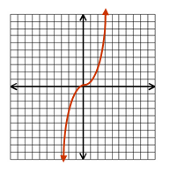
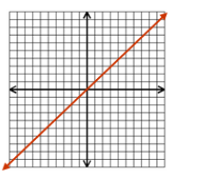

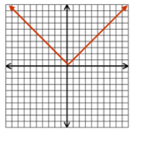
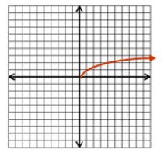

For #’s 2-4 Describe the transformation for each function given the parent function.
2. Parent function: g(x) = x² Function after transformation: g(x) = 3(x – 1)² – 6

3. Parent function: f(x) = x³ Function after transformation: f(x) = 5(x – 2)³ – 11

4. Parent function: h(x) =$\left|x\right|$ Function after transformation: h(x) = $\frac{2}{3}\left|x+6\right|$
For #’s 5 and 6 Name the Parent Function, describe the transformation, and graph each equation.

5. f(x)= $2\left|x-3\right|+2$

6. g(x) = $\sqrt{x+5}-3$

