Name: ___________________________________ Date: ___________
Common Core Algebra

Step Functions
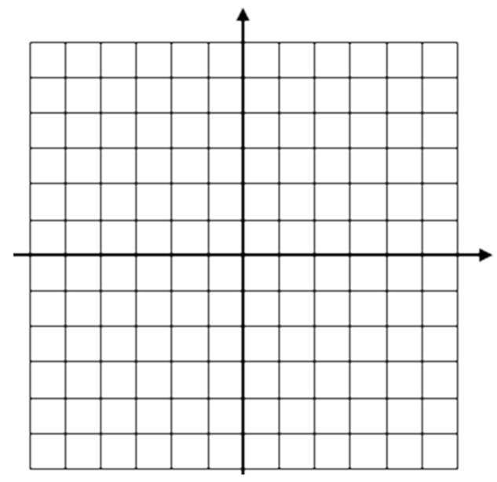
Do Now:
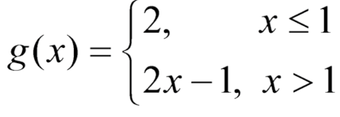
Graph the following function

1. A step function is defined using the piecewise formula

(a) Evaluate the following:
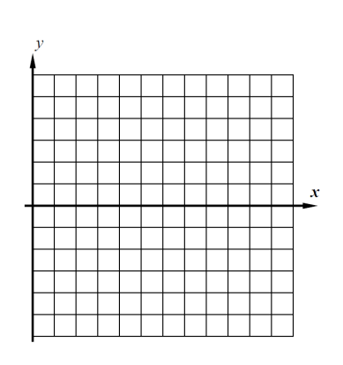
f(2.7) = f(5) =
f(3.5) = f(0) =

(b) Graph f(x) on the grid to the right.

2. Your family data plan allows for you to use at most 5 GB for 40 dollars per month. If you use more than 5GB, up to 8 GB you must pay 60 dollars for the month. If you use more than 8 GB, you must pay 100 for the month. Graph this on the axes provided. (Hint, scale the y-axis appropriately).

3. You are working as a software developer for Pied Piper Inc. Your pay depends on hours worked, it is as follows. If you work for up to 10 hours, you are paid $500. If you work 10 hours to 20 hours, you are paid $1,000. If you work over 20 hours, up to 40 hours, you take home $2,500. Indicate this on the graph below
4. When kimchi is made, it is initially fermented for the first 3 days at a temperature of 70 degrees Fahrenheit and then immediately moved to a temperature of 50 degrees Fahrenheit for another 3 days after which it is put in a 35 degree refrigerator for 6 days.

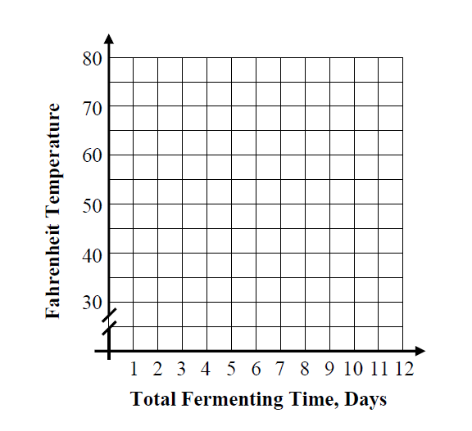
The Fahrenheit temperature, F, of the kimchi can be modeled over time, t, in days with the equation below. Graph the kimchi’s temperature on the grid provided.

5. An electrician works at a job site at a rate of $40 per hour or any portion of an hour. In other
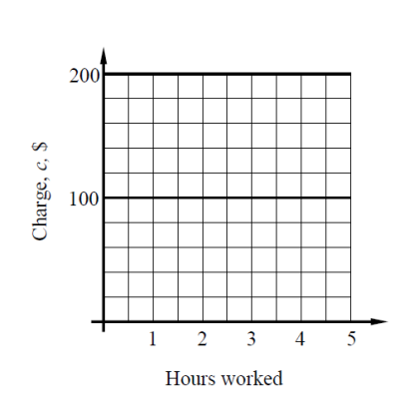
words, he will charge you $40 as soon as he comes up to the first hour, and then $40 for the second hour, and so on.

(a) Graph the amount the electrician charges, c, in dollars as a
function of the number of hours he works.

(b) How much does he charge for working 3.5 hours? Circle
the point on the graph the shows this answer.

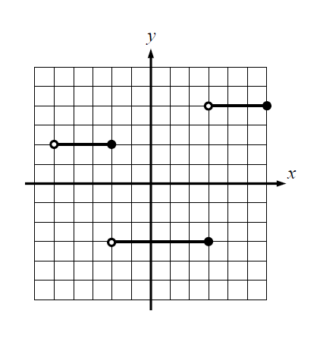
6. The step function g(x) is shown on the grid to below. Answer the following questions.

Evaluate each of the following:

f (–4) = f (–2) =
f (2) = f (5) =

7. Graph the following step function:

$$f\left(x\right)=\left\{\begin{aligned}\begin{aligned}-6, &-2<x≤3 \\ 1, &3<x≤5\end{aligned} \\ 5, 5<x≤6\end{aligned}\right.$$

