Name: ____________________________________ December 12, 2016

Teacher: _________________________________ CC Algebra

Graphical Features - Practice

Example 1
Domain:
Range:
y-intercept:
Zeroes:
Absolute min:
Absolute max:
Relative min coordinate:
Relative max coordinate:
Increasing:
Decreasing:
Positive:
Negative:
f(1) =
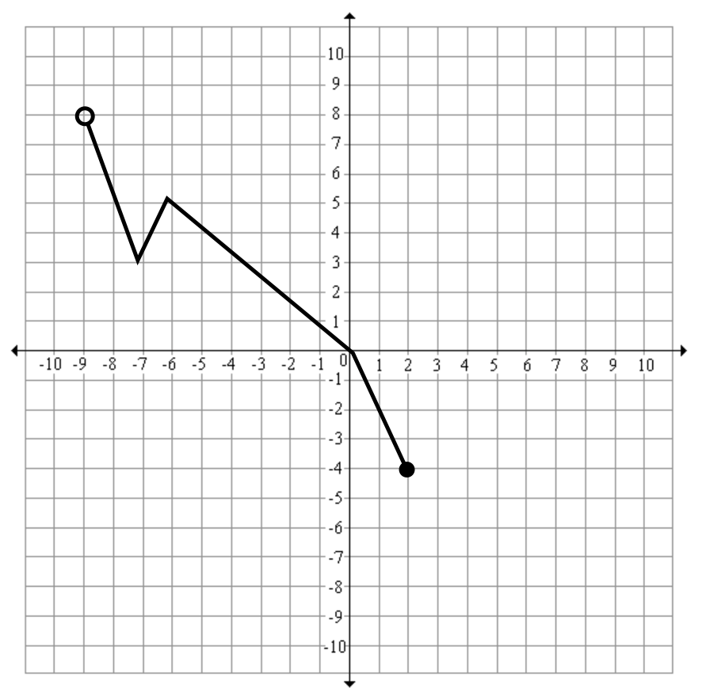

Example 2
Domain:
Range:
y-intercept:
Zeroes:
Absolute min:
Absolute max:
Relative min coordinate:
Relative max coordinate:
Increasing:
Decreasing:
Positive:
Negative:
f(x)= 4; x =
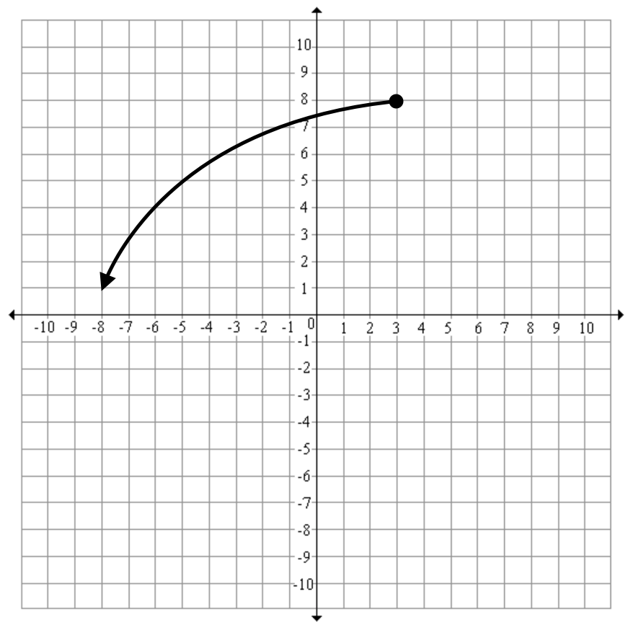

Example 3
Domain:
Range:
y-intercept:
Zeroes:
Absolute min:
Absolute max:
Relative min coordinate:
Relative max coordinate:
Increasing:
Decreasing:
Positive:
Negative:
f(x) = -7; x =
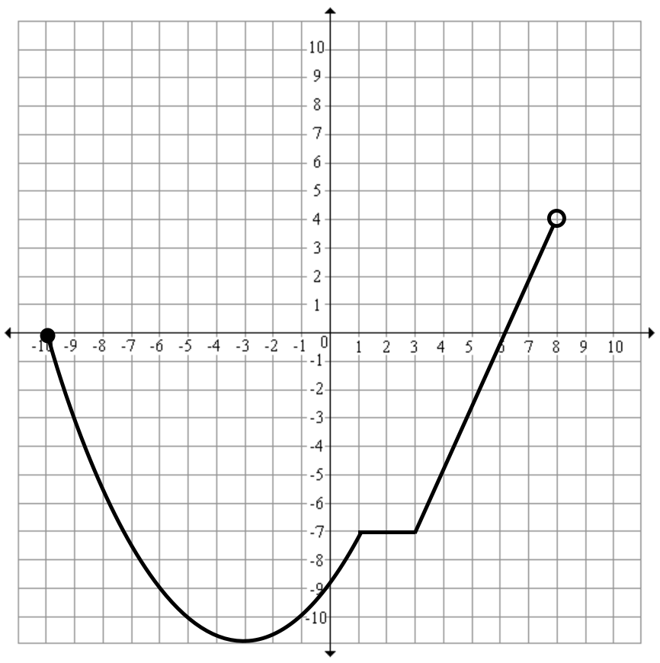

Example 4
Domain:
Range:
y-intercept:
Zeroes:
Absolute min:
Absolute max (estimate):
Relative min coordinate:
Relative max coordinate:
Increasing:
Decreasing:
Positive:
Negative:
f(2) =
