Name: ______________________________________ November 30, 2016

Teacher: ___________________________________ CC Algebra

The outside temperature varies throughout the day. The graph shows the outside temperature for a day at one location from midnight to midnight. 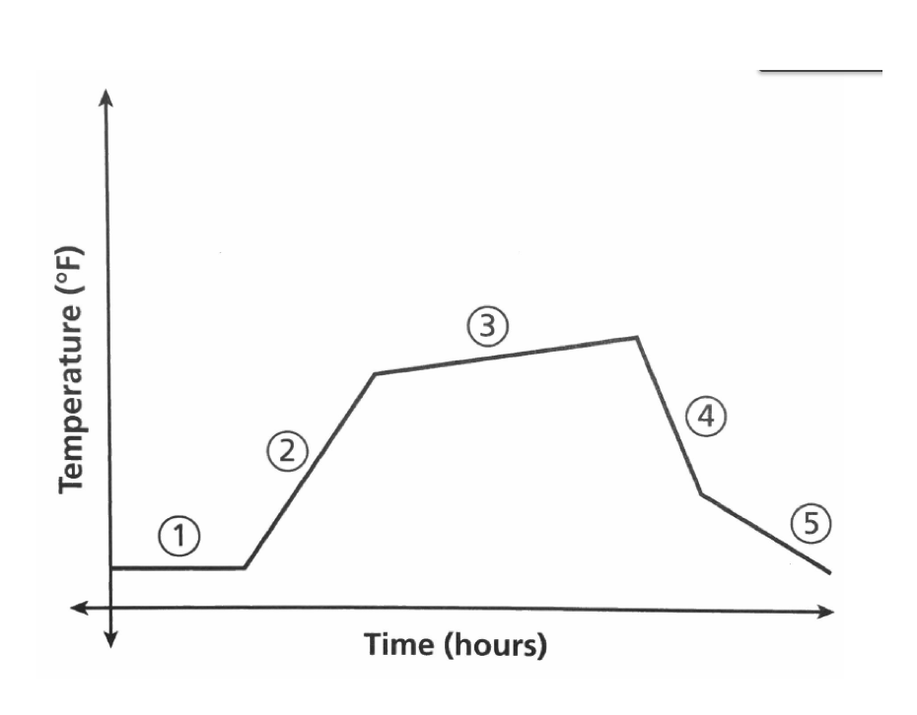

- Based on the time frame, give a possible explanation for the change in temperature represented by segment 2.

- Which segments of the graph show decreasing temperatures? Give a possible explanation.

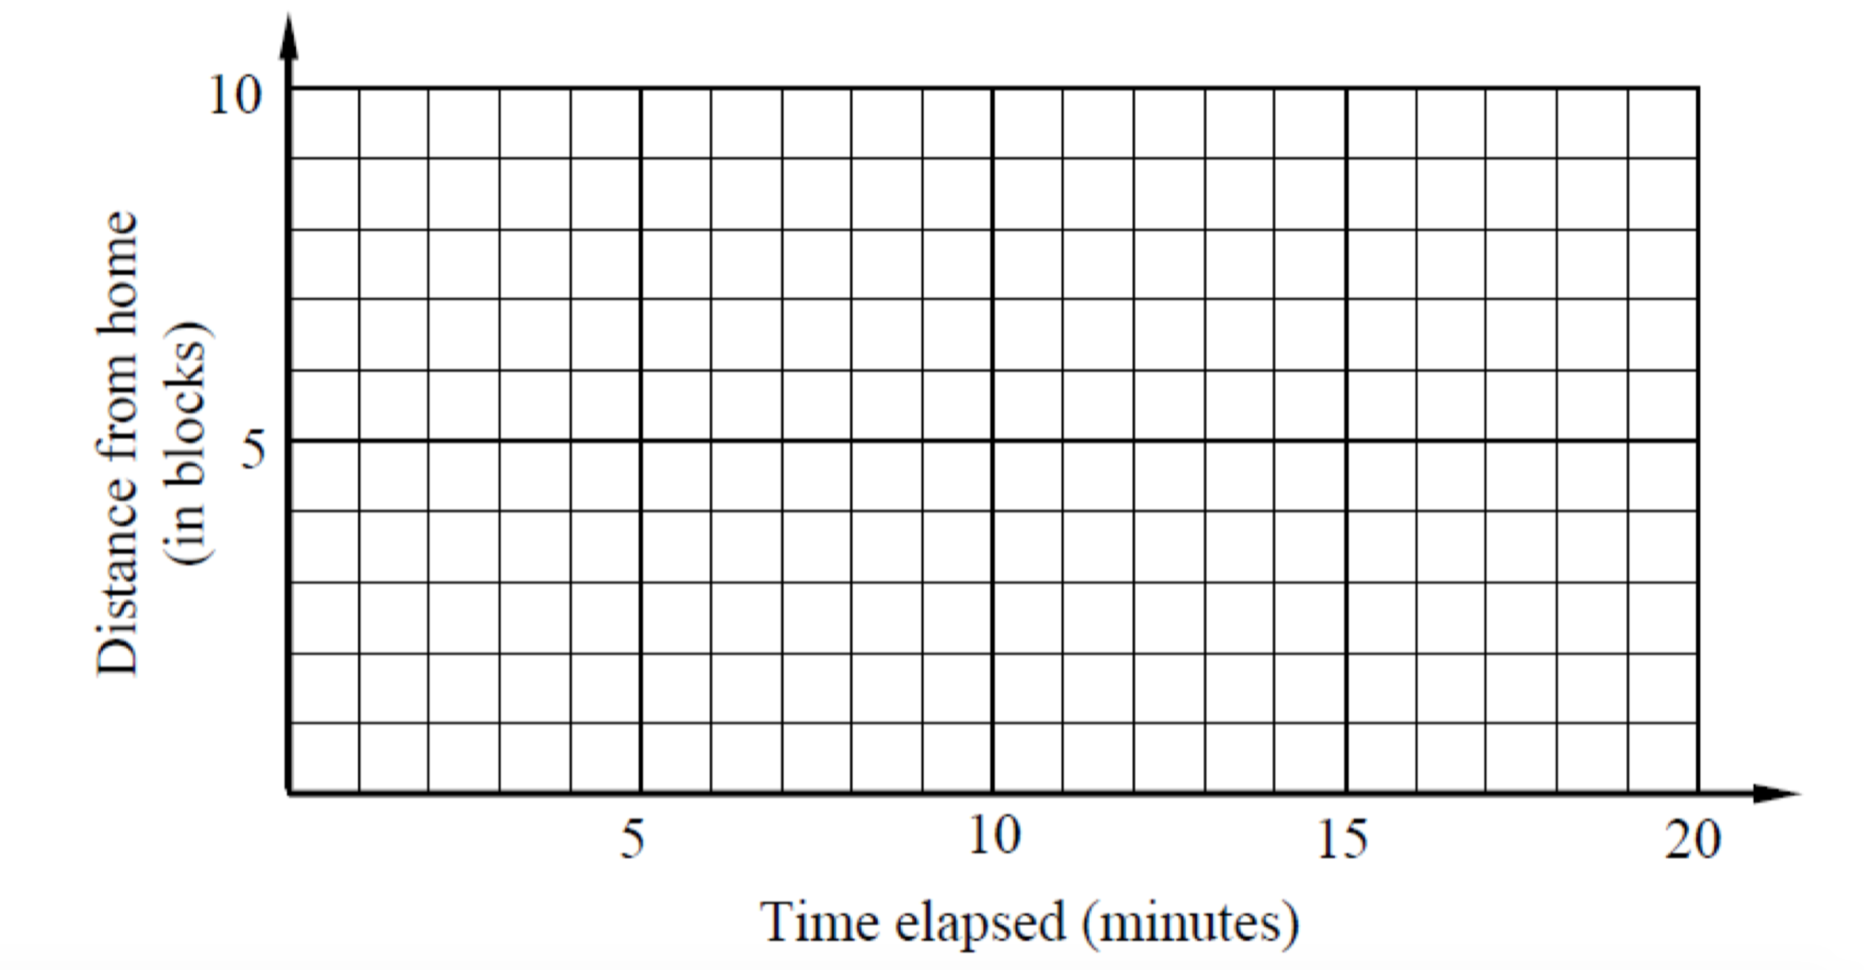
Liza has a few items she needs to pick up from a grocery store 8 blocks away. Liza travels at a constant rate of 2 blocks per minute when not stopped at a light. On her way to the grocery store she doesn’t hit any red lights and the trip takes her four minutes. She spends 8 minutes in the grocery store and then starts to head home. When she’s halfway home she hits a red light that lasts 3 minutes. After the light ends, she then drives the second half of the way home.

Name: ______________________________________ November 30, 2016

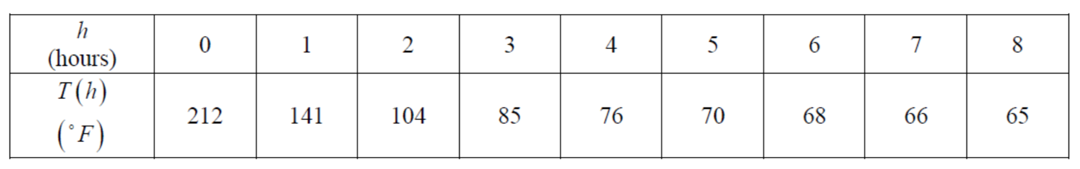
2) Boiling water at 212 degrees Fahrenheit is left in a room that is at 65 degrees Fahrenheit and begins to cool. Temperature readings are taken each hour and are given in the table below. In this scenario, the temperature, T, is a function of the number of hours, h.
- Evaluate T(2) and T(6)

- For what value of h is T(h) = 76?

- Between what two consecutive hours will T(h) = 100? Explain how you arrived at your answer.

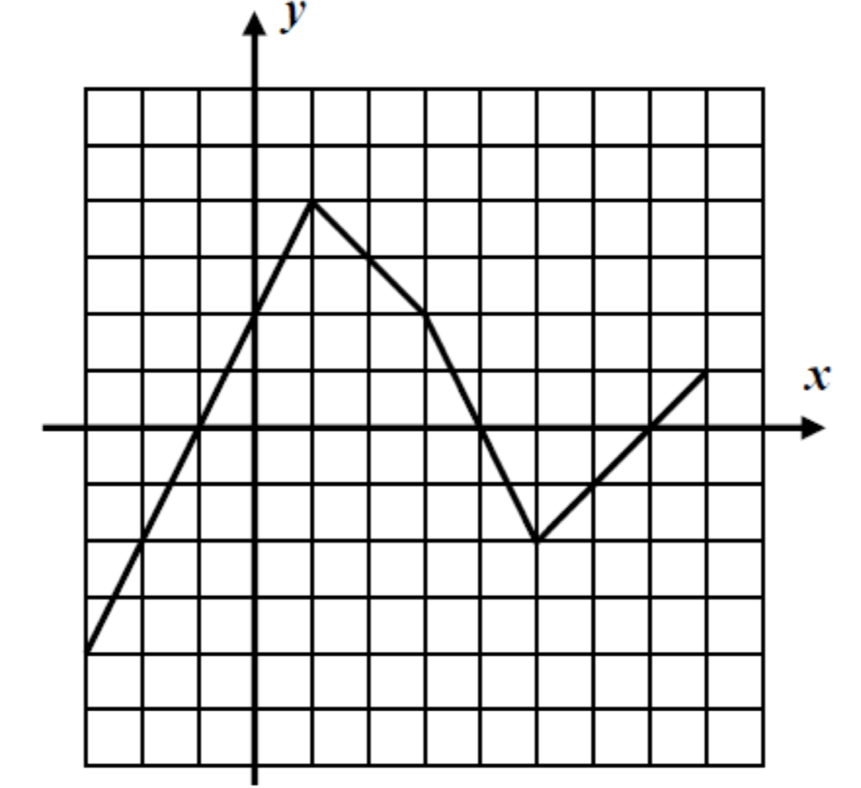
3) Use the graph below to answer the following
(a) Evaluate each of the following:

f(1) = f(5) =

f(-3) = f(0) =

(b) Solve each of the following for all values of the input, x, that makes them true.
f(x) = 0 f(x) = 2

(c) What is the largest output achieved by the function? At what x-value is it hit?
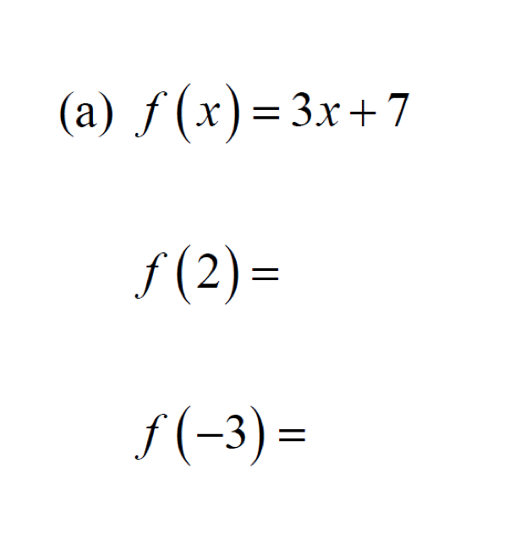
4) For each of the following functions, find the outputs for the given inputs.

