Name____________ November 17, 2017
CC Algebra

Intro to Functions Homework

Complete the Following for 1-3:
a. Identify Domain
b. Identify Range
c. Create Map Diagram
d. Identify if Relation is a function
______________________________________________________________________________

- { (1,-2), (2,-4), (3,-6) } Mapping Diagram:

Domain:____________

Range:_____________

Function?__________

- {(1,2), (4,3), (1,4), (-1,5)} Mapping Diagram:

Domain:_____________

Range:______________

Function?____________

- { (5,0), (-4,3), (0,3), (1,4), (2,2) } Mapping Diagram:

Domain:

Range:

Identify Function Using the Vertical Line Test:

4) 5)
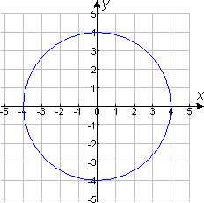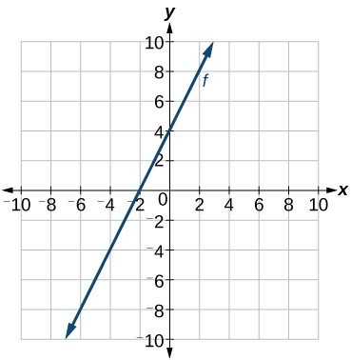

Function?_______________ Function?_________________

6) 7)
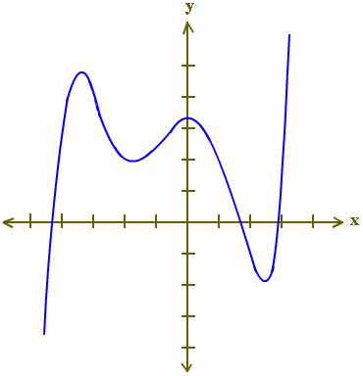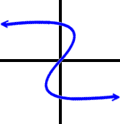

Function?_________________ Function?__________________

