Name: ___________________________________ December 15, 2017

Teacher: _________________________________ Common Core Algebra

Step Functions Homework

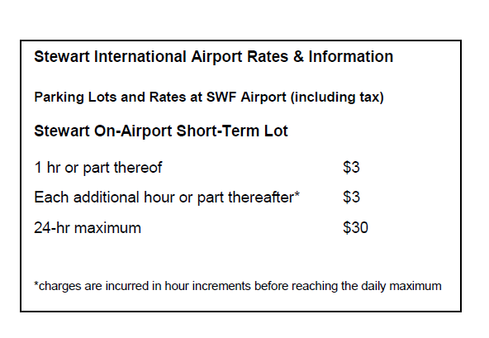
1. Stewart International Airport in Newburgh, New York charges for parking the way many airports do, by the partial hour. Their short-term parking rates are shown below.

(a) Explain why the total amount you will pay for
parking at Stewart is a step function based on
the number of hours you’ve parked?

(b) How much would you have to pay if you parked for 5 hours and 22 minutes? Show how you
determined your answer.

(c) After how many hours of parking will you hit the maximum charge of $30? Explain your reasoning.
2. A pumping station is draining a reservoir with a set of pumps that drain the water at a rate of 250
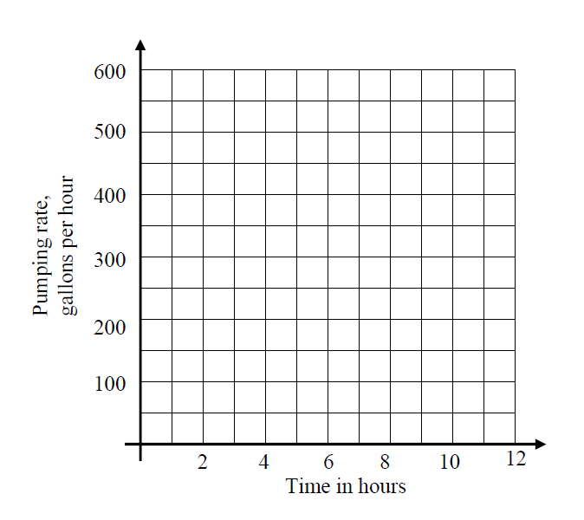
gallons per hour. After 5 hours, additional pumps are turning on such that they pump at an overall rate of 600 gallons per hour for the next 7 hours.

(a) Draw a graph of the pump rate function on
the grid provided.

(b) How many total gallons of water are pumped
out of the reservoir over the 12 hour period?
Show the calculations that lead to your
answer.

(c) The reservoir originally contains 8,250 gallons of water. How much does it contain after 5 hours if water is only pumped out? Show the work that leads to your answer.

(d) Engineers want to turn off the pumps when the reservoir reaches a level of 2,000 gallons. Will they need to turn the pumps off during this 12-hour time period? Show evidence to support your yes/no answer.

