Name: __________________________________ December 20, 2016

Teacher: ________________________________ CC Algebra

Graphical Features Practice

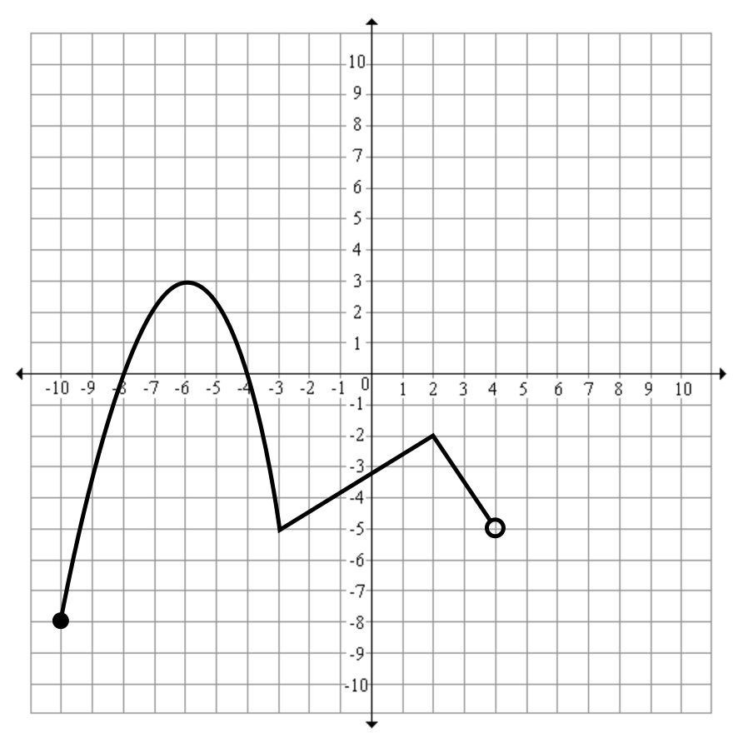
1. Given the function y = f(x) defined by the graph below, answer the following questions.

  - Find the value of each of the following:

$f(-6)$ $f(-10)$

$f(2)$ $f(-3)$

  - Find the value of each of the following:

$f(x) = 3;$ x =

  - State the zeros of the function.

  - State the domain ______________ and the range ______________

  - Absolute minimum value ______________ and absolute maximum value ______________

  - For how many values of x does f(x) = -5? _______________

  - Name one interval that is increasing; _______________

and one that is decreasing: _______________

  - Name one relative maximum (that is not the absolute) _______________

and one relative minimum (that is not the absolute) _______________

  - Name one negative interval _______________ and one positive interval _______________

2. Given the graph below, answer the following questions.

- What is the absolute maximum?

- What is a relative minimum?

- Why is there no absolute minimum?

- What is the domain?

- What is the range?

- What are the coordinates of the zeroes?

- Name an interval that is increasing.

- Name an interval that is decreasing.

- Name an interval that is positive.

- Name an interval that is negative.

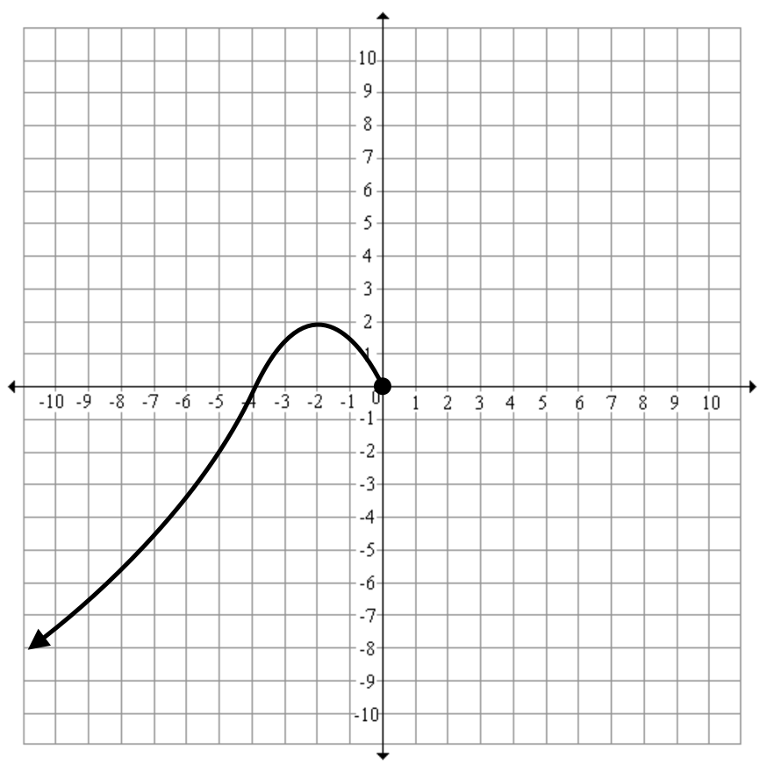

3. Given the graph below, answer the following questions.

- What is both the minimum?

- What is the maximum?

- What is the domain?

- What is the range?

- What is the zero?

- What is the y-intercept?

- Name an interval that is increasing.

- Name an interval that is decreasing.

- Name an interval that is positive.

- Name an interval that is negative.

