**Name: ____________________________________ Date: __________________**

**CC Algebra**

**Piecewise Functions**

Evaluate the following for *f(x)* = $\left\{\begin{aligned}3x-5, x>4 \\ x^{2}, x ≤4\end{aligned}\right.$

1. f(7) 2. f(4) 3. f(-3)

Evaluate the following for *f(x)* =

4. f(10) 5. f(2) 6. f(0)

Graph the following piecewise functions.

7. *f(x)* =

8. *g(x)* =



9. *h(x)* =

10. *f(x)* =

11. *g(x)* =



12. *h(x)* =

13. Write the function for the given graph.

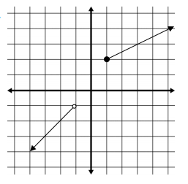

14. Write the function for the given graph.

