**Name: __________________________________ Date: _________**

**CC Algebra**

**Functions Practice**

1. Which relation is *not* a function?

A) {(1, 5), (2, 6), (3, 6), (4, 7)} C) {(–1, 6), (1, 3), (2, 5), (1, 7)}

B) {(4, 7), (2, 1), (–3, 6), (3, 4)} D) {(–1, 2), (0, 5), (5, 0), (2, –1)}

2. Which graph represents a function?

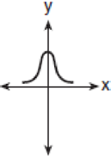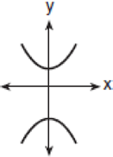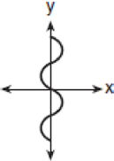

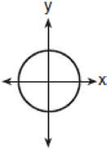A) B) C) D)

3. Given h(*x*) = –3x + 4. What is the value of *x* for which h(*x*) = 17?

A) –47 B)  C) –51 D) –7

4. For what value of ***x*** is the relation {(-3, 1), (0, -2), (***x***, 5), (2, 3), (–1, 7)} ***not*** a function?

A) –2 B) 4 C) 3 D) 0

5. If , find the following:

(a) (b)

6. The function $y=f(x)$ is shown below over the interval $-5≤x≤5$.

1. 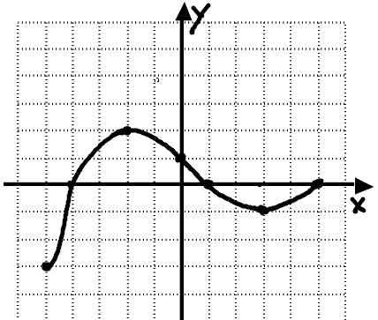Evaluate each of the following:

$f\left(-2\right)=$ $f\left(0\right)=$

1. Use your graph to find all solutions (zeroes) to the

equation $f\left(x\right)=0$.

1. Find the average rate of change in the interval of [-2, 5]

7. Consider the piecewise function given by $h\left(x\right)= \left\{\begin{aligned}\frac{1}{2}x+3 x≤0 \\ x^{2}-3 x>0\end{aligned}\right.$

Show a table of values and graph the function.

8. Karen is on the beach and throws a seashell straight up. The equation that models that flight

is *h*(*t*) = -16*t*2 + 96*t*, where *t* is the time in seconds, and *h(t)* is the height.

|  |  |
| --- | --- |
| ***t*** | ***h(t)*** |
| 0 |  |
| 1 |  |
| 2 |  |
| 3 |  |
| 4 |  |
| 5 |  |
| 6 |  |

(a) Complete the table of values

(b) Explain what *h*(4) = 128 means in relation to the problem

(c) What was the maximum height the seashell reached?

(d) How long did it take the seashell to come back down and hit the

ground?

9. Joey forgot his book at his friend’s house which is 12 blocks from his house. Draw and label a graph below showing his trip starting at his house and returning back home based on the following information: When Joey left his house he ran at a pace of 3 blocks per minute for 3 minutes. He then walked the rest of the way to his friend’s house at a rate of 1 block per minute. He stayed at his friend’s house for a total of 5 minutes. On his way back home he ran half way, then stopped for a 1 minute rest, and then walked the rest

Total time elapsed (In minutes)

Distance from home

(in blocks)

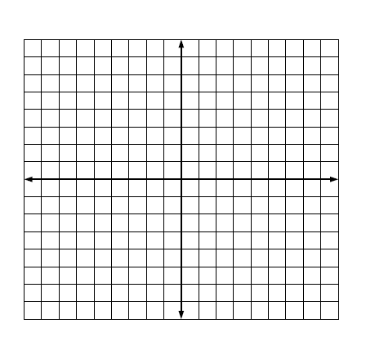10. Graph the following piecewise defined function on the axes provided.



11. Evaluate the piecewise function for each value of x.



f(3) = f(-4) = f(-2) =