Name: ___________________________________ December 14, 2016
CC Algebra

Piecewise Functions

1) $f\left(x\right)=\left\{\begin{aligned}2x+6 x<0 \\ 6-x x≥0\end{aligned}\right.$

- Evaluate the following

f(4)= f(-3) =

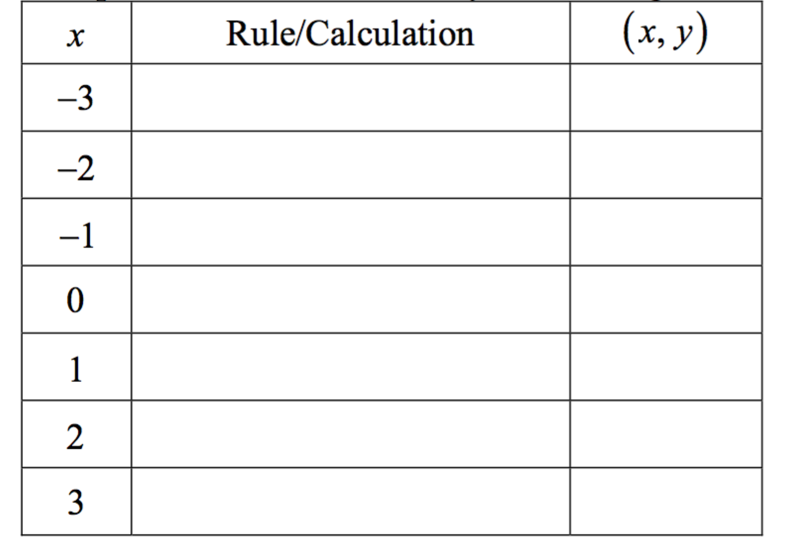
- Fill in the table below for the input values given

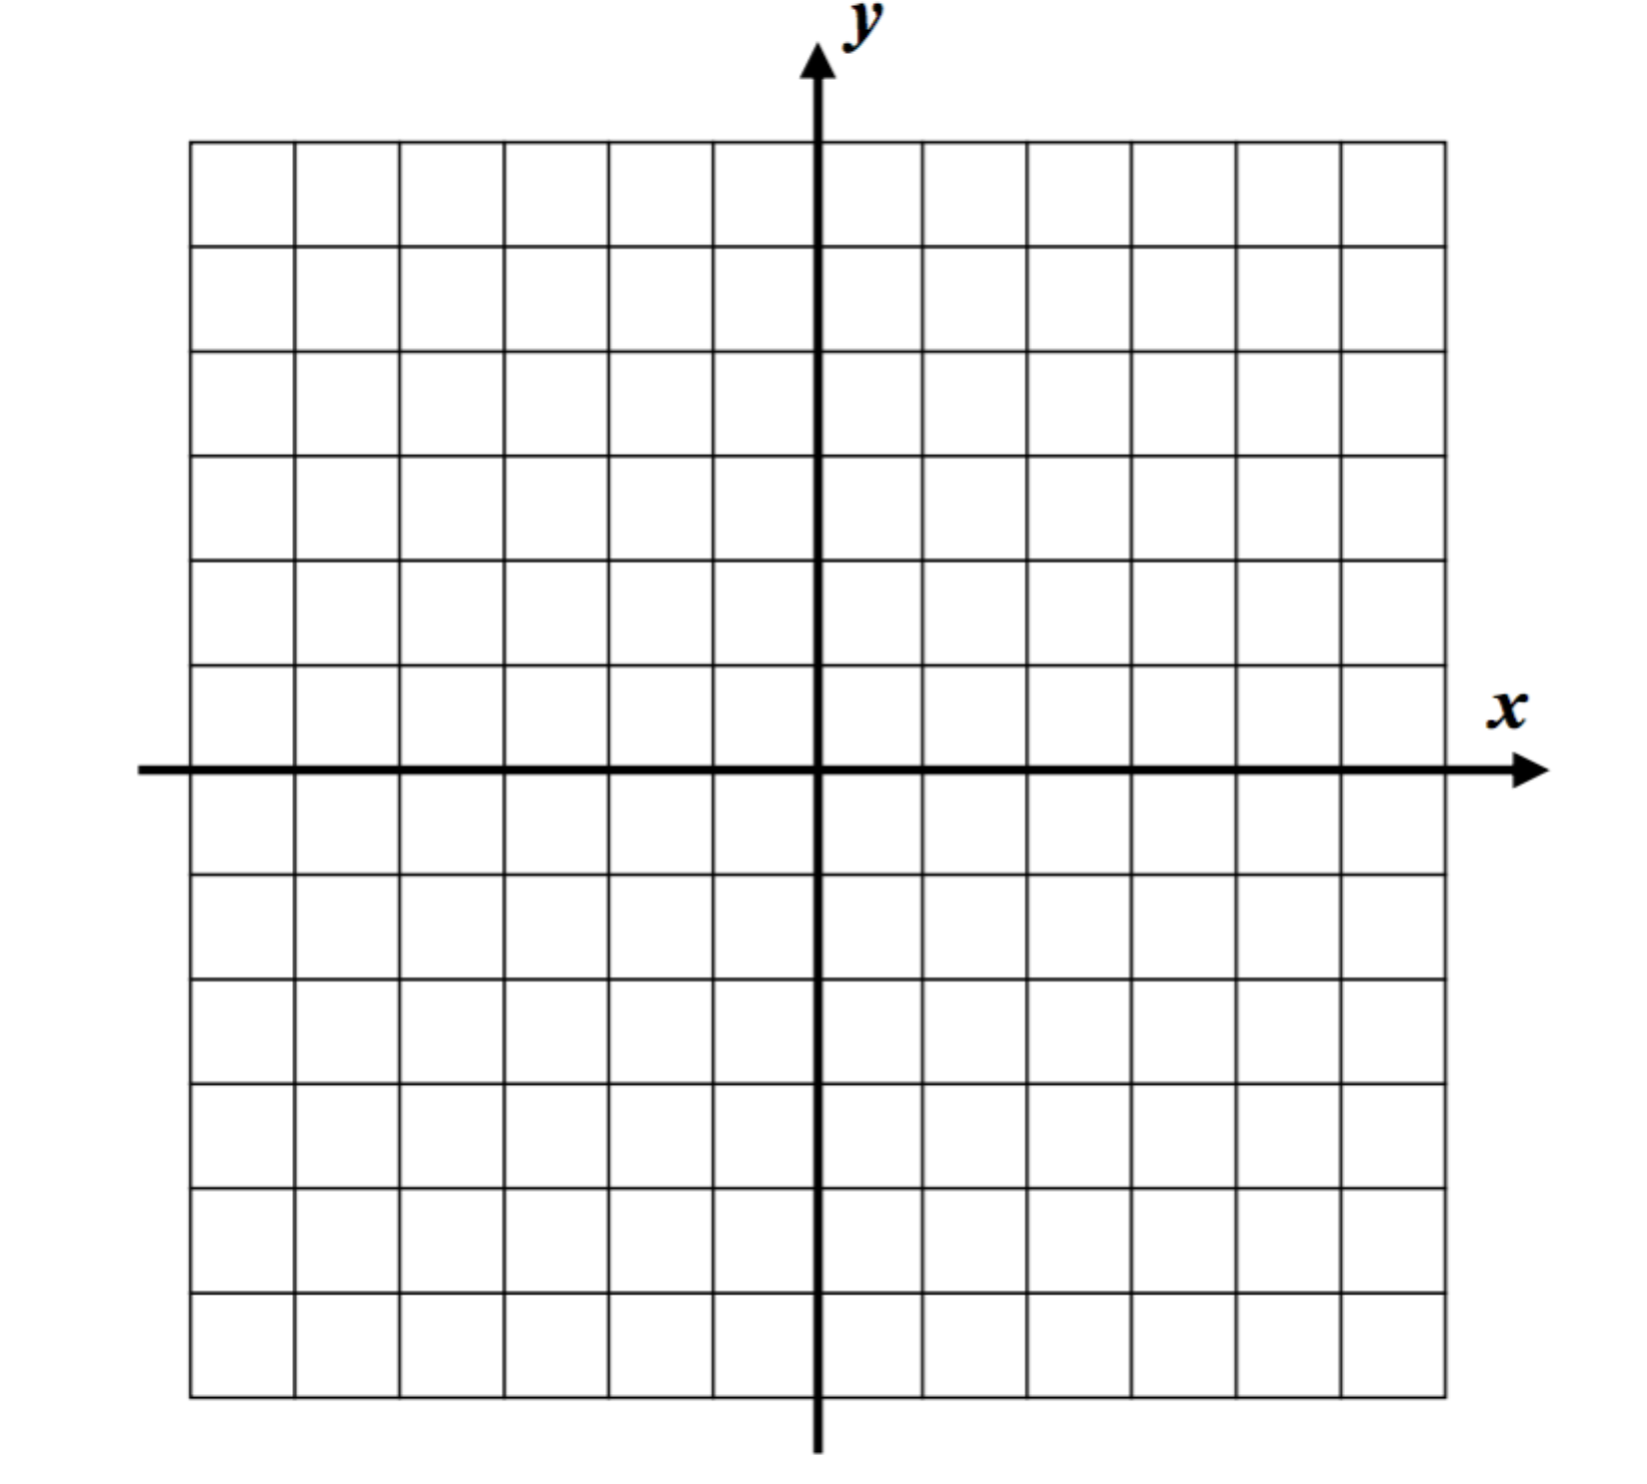

- Graph y = f(x) on the graph below

2) Graph the piecewise function using a table of values $f\left(x\right)=\left\{\begin{aligned}x+5 x<-2 \\ -2x-1 x≥-2\end{aligned}\right.$

3) $f\left(x\right)=\left\{\begin{aligned}3-2x x≤1 \\ 2x-1 x>1\end{aligned}\right.$

- Evaluate the following

f(5)= f(-2) =

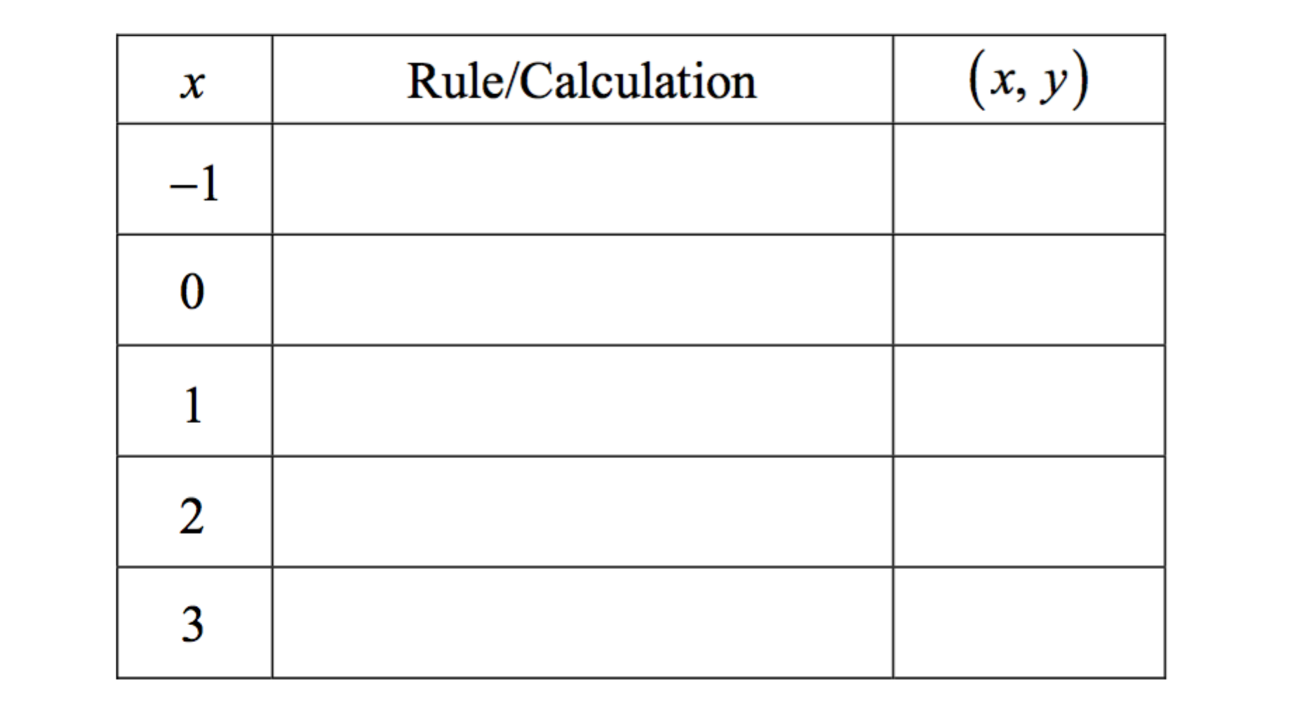
- Fill in the table below for the input values given

- Graph y = f(x) on the graph below

