Name: _________________________________ Date:____________________________

Teacher: _______________________________ Math 8

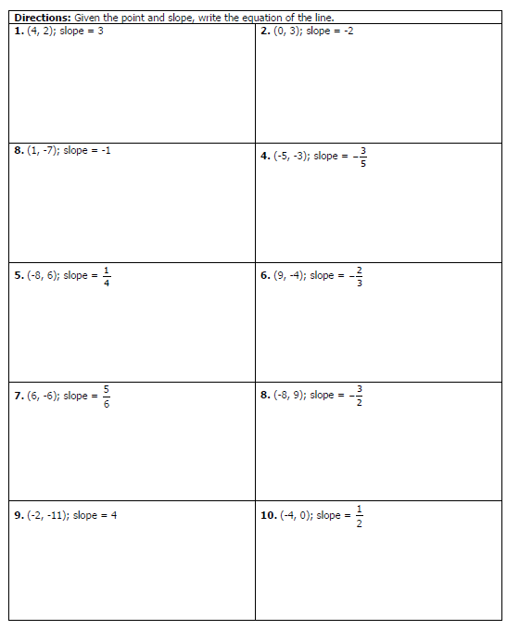

**Find the Equation of the Given Lines**

**11) _______________________________ 12) _______________________________** 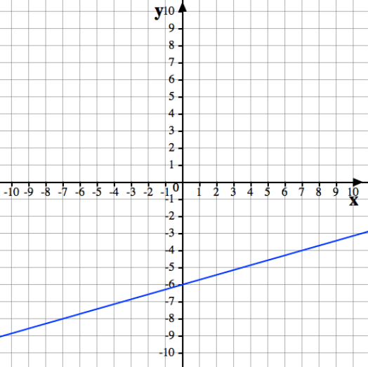 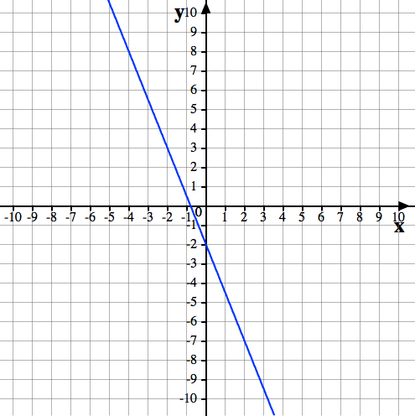

**13) _______________________________ 14) _______________________________**

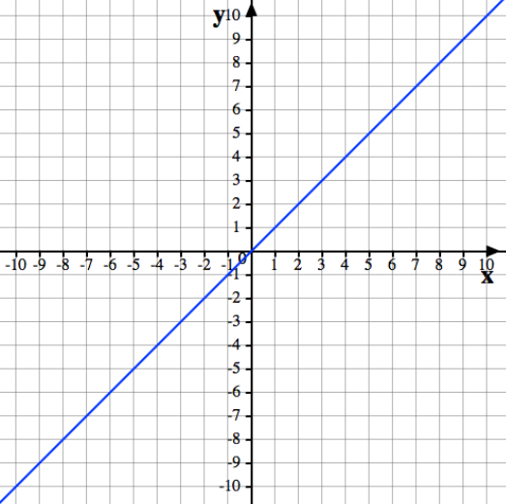 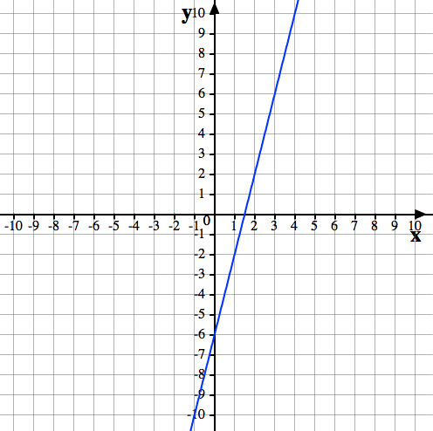

**15) _______________________________ 16) _______________________________** 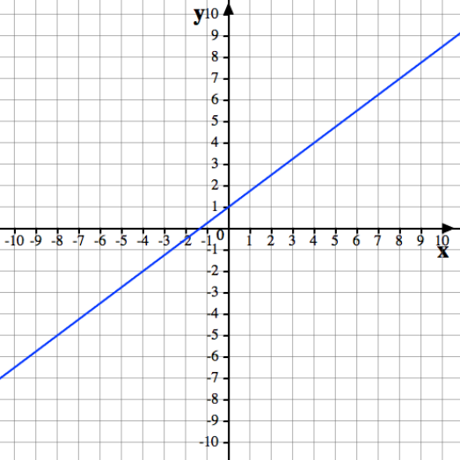 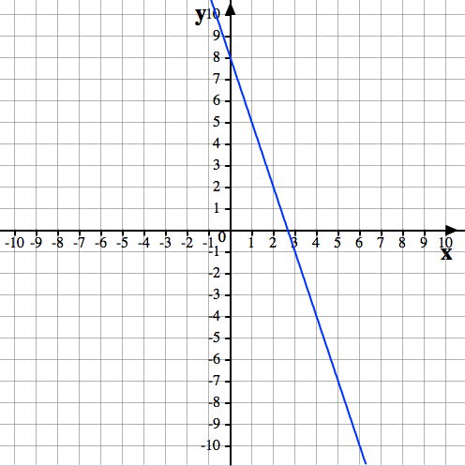

**17) _______________________________ 18) _______________________________** 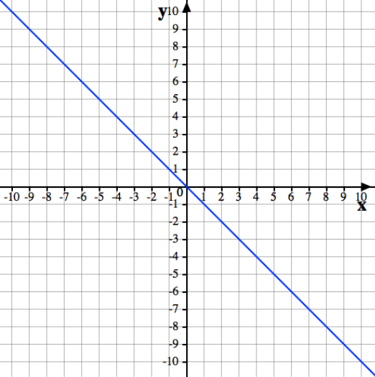 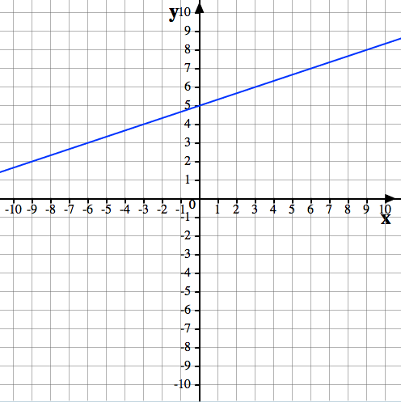

**19) _______________________________ 20) _______________________________**

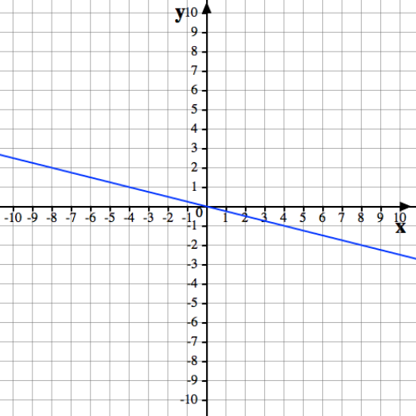 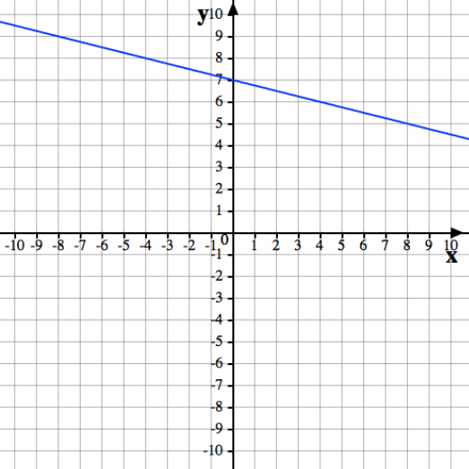

**21) _______________________________ 22) _______________________________** 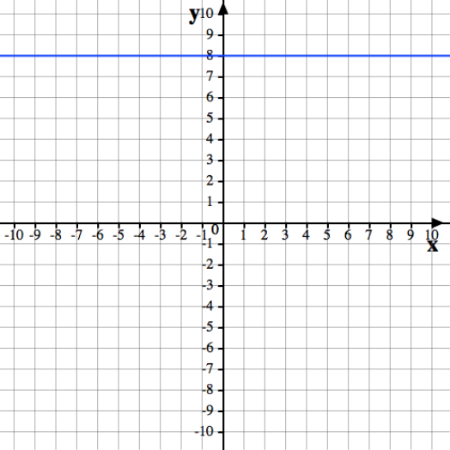 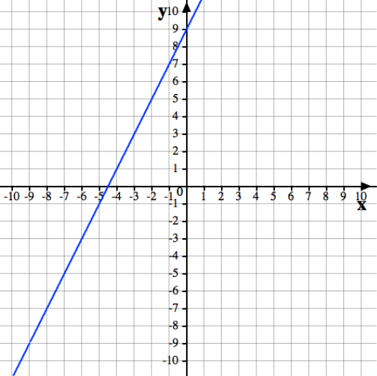

**23) _______________________________ 24) _______________________________**

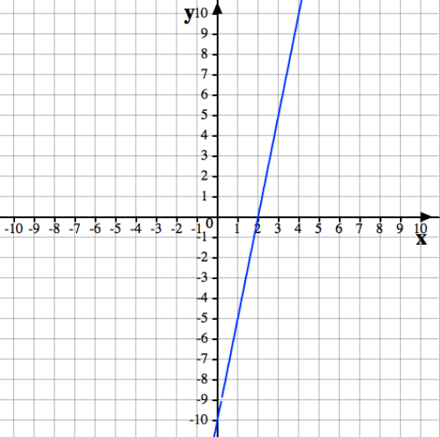 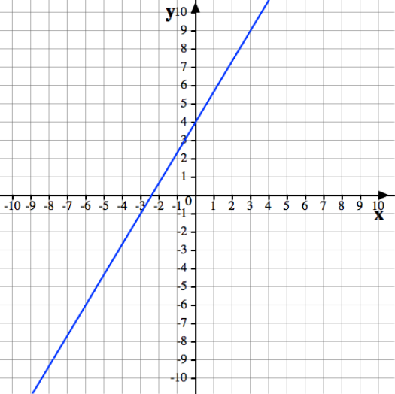

**25) _______________________________ 26) _______________________________** 