Name_________________ Date_____________
Math 8
Horizontal/Vertical Lines and Intercepts

Graph AND Label the following:
- y= -4
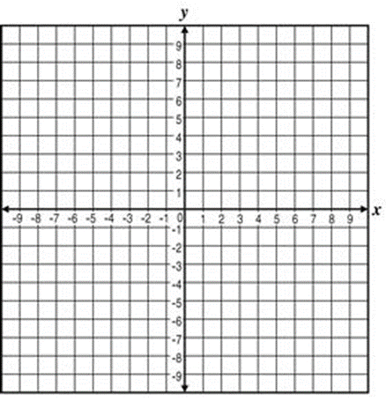

- x = 6

- y = 0
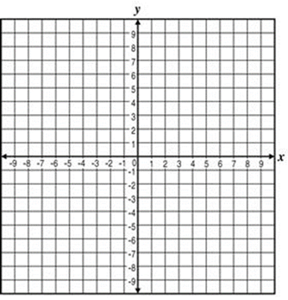

- x = -1

Graph and Identify x and y intercepts
- { (-4,-4), (-2,-2), (0,0), (1,1), (2,2)}
x-intercept:_________
y-intercept:_________

6)
X | Y
-1 | 4
0 | 2
1 | 0
2 | -2
3 | -4
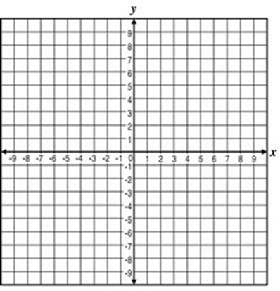
x-intercept:________
y-intercept:________
- {(-8,-2), (-6,0), (-3,3), (0,6), (2,8)}
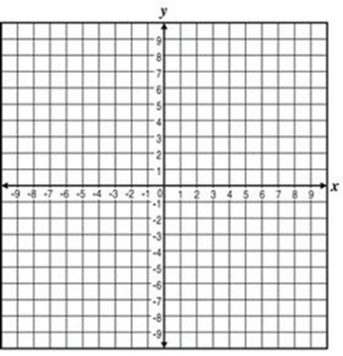
x-intercept:___________
y-intercept:___________

- {(6,1), (3,-2), (-1,-6)}
x-intercept:_________
y-intercept:_________

