Name: ______________________________ Date: _____________

Teacher: ____________________________ Math 8

Cumulative Review #3.2

**Show work for all questions for full credit**

**& write your answers on the lines provided!!!**

(*If you feel no work is needed you must explain your reasoning.)*

|  |  |  |
| --- | --- | --- |
| 1. | A football team gains 2 yards on the first play, loses 5 yards on the second play, loses 3 yards on the third play, and gains 4 yards on the fourth play. What is the team’s overall gain or loss for all four plays? | |
|  | A. | A gain of 14 yards |
|  | B. | A gains of 2 yards |
|  | C. | A loss of 2 yards |
|  | D. | A loss of 14 yards |

1. ____________________

2. What is the equation of the line with a slope of − that passes through the point (6, −6)?

A. y = −x – 3

B. y = x – 3

C. y = −x + 3

D. y = −2x – 3

2. ______________________

3. An investor bought 3 shares of stock A and 2 shares of stock B for a total of $41. Stock A costs $2 more per share than stock B. What is the cost of a share of stock A in dollars? *[Only an algebraic solution will be accepted!]*

3. ________________________

4. Find the m<AHG:

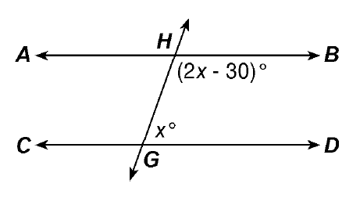

4. ______________________

5. Graph the following linear equation

2x + 4y = −8