Name: __________________________________ October 11, 2018

Teacher: ________________________________ CC Algebra

**Graphing Review Homework**

1. 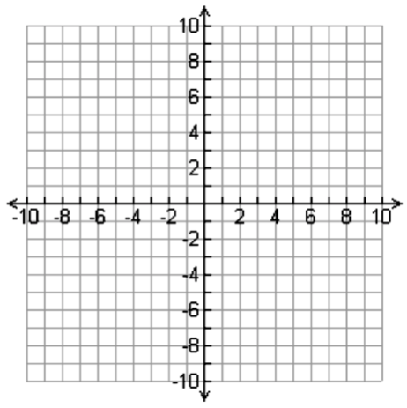 y = -x + 3 2) 
2.  4) 
3. y = 2x + 5