Name: _____________________________________ October 14, 2016
CC Algebra
Evaluating Functions – Homework

- g(x) = 3x – 8
  - g(1)

  - g(-3)

  - g(0)

- f(x) = x² – x
  - f(-4)

  - f(-1)

  - f(7)

- f(x) = -x² + 6x – 4
  - f(-3)

  - f(-1)

  - f(5)

- g(x) = $-\frac{1}{2}$x + 9
  - g(-8)

  - g(-2)

  - g(0)

- h(x) = 2 – 4x
  - h(-5)

  - h(-2)

  - h(4)

- f(x) = 2x² + 4x – 9
  - f(-8)

  - g(-5)

  - f(-2)

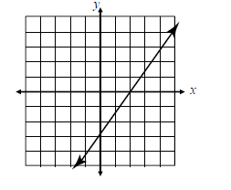
- Given the graph of the function f(x), find each of the following
  - f(0)

  - f(2)

