Name: ___________________________________ Date: _____________
CC Algebra
Inequality Word Problems

1. Paul earns $25.00 per hour at his job. Each
day he spends $10.00 for lunch. Today he
wants to take home at least $215.00 after
paying for his lunch. How many hours will he
have to work to achieve his goal?

2. Sally rented a car for $45.00 a week plus
$0.12 for each mile the car is driven. What is
the greatest number of miles Sally can drive
the car if she wishes to spend at most $105?

3. For what values of x is the area of the
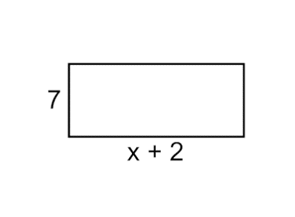
rectangle greater than the perimeter?

4. Two consecutive odd integers have a sum of
more than 26. Find the two smallest odd
integers that will make this true.

5. Sophia types 75 words per minute and is just starting to write a term paper. Patrick already has 510 words written and types at a speed of 60 words per minute. For what number of minutes will Sophia have more words typed than Patrick?

6. You rent a car and are offered 2 payment options. You can pay $25 a day plus $0.15 a mile (Option A) or you can pay $10 a day plus $0.40 a mile (Option B). For what amount of daily miles will Option A be the cheaper plan?

7. Members of the marching band are planning to sell programs at football games. The cost to print the programs is $150 plus $0.50 per program. They plan to sell each program for $2. How many programs must they sell in order to make a profit?

