Name: ____________________________________ Date: _____________________
CC Algebra
Statistics – Bivariate Data & Linear Regression
Exercise #1: A survey was taken of 10 low and high temperatures, in Fahrenheit, in the month of April to try to establish a relationship between a day’s low temperature and high temperatures. 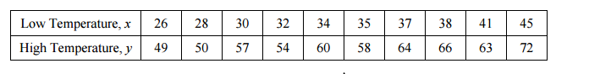
(a) Construct a scatter plot of this bivariate data set on the grid below.
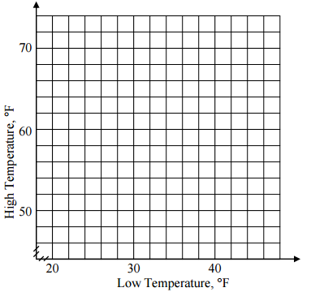
(b)Enter data into lists (L1 & L2) on your calculator.

(c) Use your calculator to find the equation for the line of best fit. Round the slope of the line to the nearest hundredth and the y-intercept to the nearest integer.

(d) Use your line of best fit to estimate the high temperature for a day in April given that the low temperature was 42 degrees.

(e) Would you characterize the relationship between the low and high temperature as a positive correlation or a negative correlation? Explain.

Exercise #2: In each of the following scenarios, two variables are given that if plotted would have a strong correlation (a scatterplot where the data falls nearly in a line). Determine if there exists a causal relationship between the two variables. If so, which variable causes the other?

- The high temperature in New York City and the number of bottles of water sold.

- A person’s height and a person’s shoe size.

- A person’s weight loss and the number of hours a person spends in the gym per week

- The years of education a person achieves and the salary that person starts at upon entering the work force.

Exercise #3: Generally, the fuel efficiency of a car changes with the weight of the car. A survey of some cars with their weights and gas mileages is shown below. 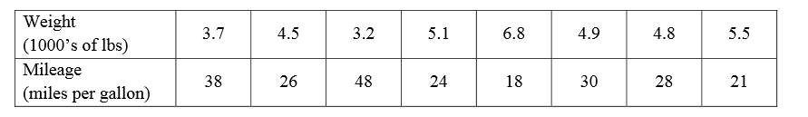
(a) Find the equation for the line of best fit using your calculator. Round both coefficients to the nearest tenth. List what the variables x and y represent in this problem.

(b) Would you consider the correlation between weight and mileage to be positive or negative? Explain.

(c) Which parameter of the linear model predicts whether the correlation is positive or negative? Use this model to help explain your answer.

(d) If a car had a weight of 4,300 pounds, what would this model predict as its fuel efficiency? Round to the nearest integer. Use appropriate units and make sense of your answer.

(e) If we wanted to purchase a car that got 40 miles to a gallon, what weight of car, to the nearest 100 pounds, should we purchase? Solve algebraically.

