Name: ____________________________________ May 8, 2018
CC Algebra
Standard Deviation & IQR – Homework
- For each of the following data sets, use your calculator to help find the interquartile range and the population standard deviation. Show your calculation for the IQR. Round all non-integer values to the nearest tenth.

- 4, 6, 8, 10, 15, 19, 22, 25
- 3, 3, 4, 5, 5, 6, 6, 7, 7, 8

- What is the interquartile range of the data set represented in the box plot shown below? 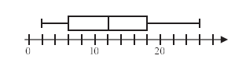

- Which of the following best measures the average distance that a data value lies away from the mean?

- Mean

- Standard deviation
- Median

- Range

- Which of the following data sets would have the largest standard deviation?

- {3, 3, 4, 5, 5}

- {72, 73, 74, 75, 76}
- {2, 8, 18, 26, 35}

- {8, 10, 12, 14. 16}

- Two surveys were completed of household that have video enabled devices (televisions, smart phones, tablets, etc). Each survey was done with 30 participants. In Survey A the survey was random, in Survey B the survey only included families with at least one teenager. The dot plots of the results are shown below.
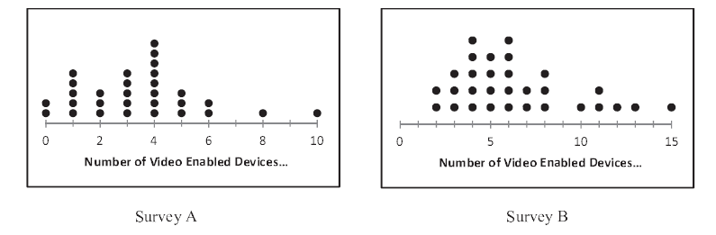
- Enter the data into your calculator and use it to calculate the mean number of devices, the interquartile range, and the sample standard deviation of both sets. Round all non-integers to the nearest tenth.

- Which of the two survey data sets had the greatest variation in the data? Explain based on the statistics you found in part A.

