Name: ____________________________________ Date: _____________________
CC Algebra
Statistics – Box Plots
Exercise #1: Shown below are the scores 16 students received on a math quiz

52, 60, 66, 66, 68, 72, 72, 73, 74, 75, 80, 82, 84, 91, 92, 98

- What is the median of this data set?

- Find the range of the data set

- What is the median of the lower half of this data set

- What is the median of the upper half of this data set

Exercise #2: Using the same data set construct a box plot on the number line given below.

Exercise #3: The ages of the 15 employees of the Red Hook Curry House are given below.
16, 17, 17, 18, 19, 22, 25, 26, 29, 33, 33, 37, 40, 42, 44
- Determine the median and quartile values for this data set

- Create a box-and-whiskers diagram below

Exercise #4: Twenty of Mr. Oliver’s physics students recently took a quiz. The results of this quiz are shown in the following box-and-whiskers diagram. Assume that all scores are whole numbers.
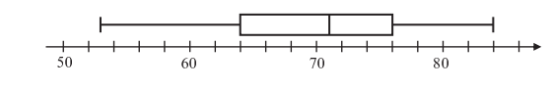

- What was the median score on Mr. Oliver physics quiz?

- What was the range of the scores on Mr. Oliver’s physics quiz?

- What score was greater than or equal to 75% of all other scores on this quiz?

- Mr. Oliver regularly sets the passing grade on his quizzes to be the score of the lower quartile. What is the passing grade on this quiz?

Exercise #5: Which of the following box plots shows a data set with the greatest median?
