Name: ____________________________________ Date: _____________________
CC Algebra
Statistics - Measure of Central Tendency
Statistics: the study of sets of __________________ ___________________

Measures of Central Tendency: a single __________________ that is representative of the __________________ as a whole.

Mean: also known as the average. The mean is found by adding up all of the given data and dividing by the number of data entries.

Median: the __________ ______________. First you arrange the numbers in order from lowest to highest, then you find the middle number by crossing off the numbers until you reach the middle.

Statistical Study: Observation of a population to obtain data

Census: A survey of people in which ____________________ ________________is counted

Sample: a __________________ of the items being studied

Fair Sample: a __________________ which reflects the whole population

Outliers: members of __________________ __________________ that are far away from the

rest of the data. Can affect the __________________.
Quantitative Data: Deals with ___________________.

-Data which can be __________________.

Dot Plot: a set of data is represented by using dots over a number line

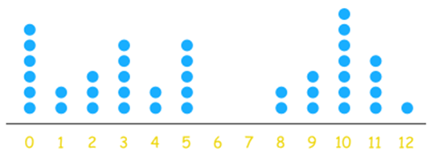

Frequency Table: is a table that shows the total for each category or group of data.

Histogram: A graphical display where the data is grouped into ranges and then plotted as bars
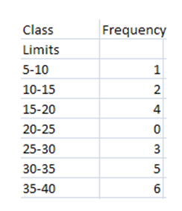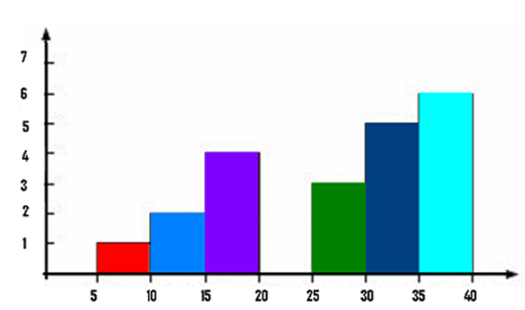

Name: ____________________________________ May 4, 2018
CC Algebra
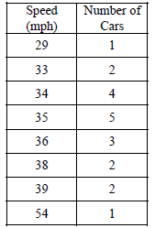
Exercise #1: Students in Mr. Okafor's algebra class were trying to determine if people speed along a certain section of roadway. They collected speeds of 20 vehicles, as displayed in the table below.
(a) Find the mean and median for this data set

(b) The speed limit along this part of the highway is 35 mph your results from part (a), is it fair to make the conclusion that the average driver does speed on this roadway?

Exercise # 2: To determine which television programs are the most popular in a large city, a poll is conducted by selecting a sample of people at random and interviewing them. Outside which of the following locations would the interviewer be most likely to find a fair sample? Explain your choice and why the others are inappropriate
(1) A baseball stadium (3) A grocery Store
(2) A concert hall (4) A comedy club

Exercise #3: A farm is studying the weight of baby chickens (chicks) after 1 week of growth. They find the weight, in ounces, of 20 chicks. The weights are shown below. Construct a dot plot on the axes given.

2, 1, 3, 4, 2, 2, 3, 1, 5, 3, 4, 4, 5, 6, 3, 8, 5, 4, 6, 3

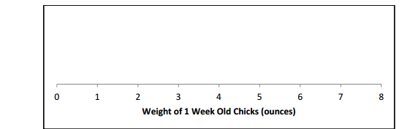

Exercise #4: The 2006 – 2007 Arlington High School Varsity Boys’ basketball team had an excellent season, compiling a record of 15 – 5 (15 wins and 5 losses). The total points scored by the team for each of the 20 games are listed below in the order in which the games were played:
76, 55, 76, 64, 46, 91, 65, 46, 45, 53, 56, 53, 57, 67, 58, 64, 67, 52, 58, 62

- Complete the frequency table below.
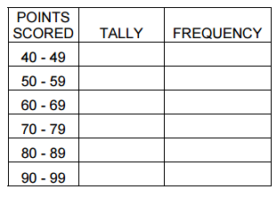
- Complete the histogram below.

Exercise #5: Charlie’s Food Factory currently employs 28 workers whose ages are shown below on a dot plot. Answer the following questions based on this plot.
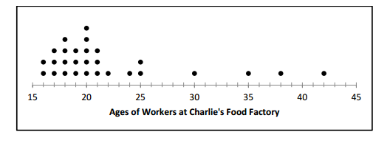

- How many of the workers are 18 years old?

- What is the range of the ages of the workers?

- Would you consider this distribution symmetric?

- The mean (average) age for a worker is 22 years old. Why is this average not representative of a typical worker?

Exercise #6: The following histogram shows the ages of the workers at Charlie’s Food Factory (from Exercise #5) but in a different format.
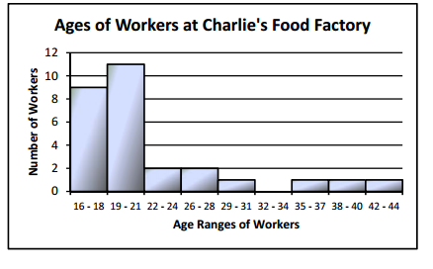
- How many workers have ages between 19 and 21 years?

- What is the disadvantage of a histogram compared to a dot plot?

- Does the histogram have any advantages over the dot plot?

Exercise # 7: Tom is trying to determine the average height of high school male students. Because he is on the basketball team, he uses the heights of the 14 players on the team, which are given below in inches.
69, 70, 72, 72, 74, 74, 74, 75, 76, 76, 76, 77, 77, 82
(a) Calculate the mean and median for this data set. Round any non-integer answer to the nearest tenth.

(b) Is the data set above a fair sample to use to determine the average height of high school male students? Explain your answer.

Exercise # 8: In Mr. Petrovic's Advanced Calculus Course, eight students recently took a test. Their grades were as follows:
45, 78, 82, 85, 87, 89, 93, 95
(a) Calculate the mean and median of this data set.

(b) What score is an outlier in this data set?

(c) Which value, the mean or the median, is a better measure of how well the average student did on Mr. Petrovic's quiz?

