Name: ____________________________________ Date: _____________
CC Algebra

Quadratic Linear Systems – Solving Graphically – Homework

- Solve the system of equations graphically
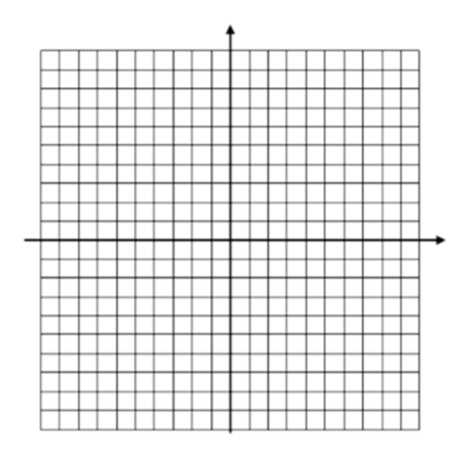
f(x) = x² – 6x + 6
g(x) = x – 4

2. The price of a stock, A(x), over a 12-month period decreased and then increased according to
the equation A(x) = 0.75x² – 6x + 20, where x equals the number of months. The price of
another stock, B(x), increased according to the equation B(x) = 2.75x + 1.50 over the same 12-
month period. Graph and label both equations on the accompanying grid.
State all prices, to the nearest dollar, when both stock values were the same.

