Name:_________________________ April 13, 2018

Teacher:_______________________ Common Core Algebra

**Quadratic Function Practice**

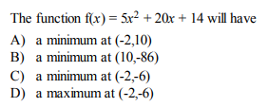



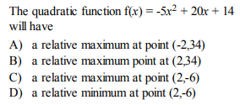



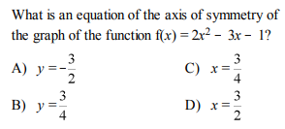



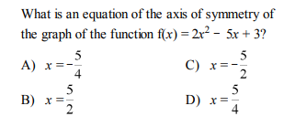

2. 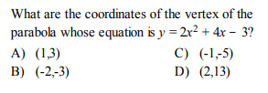

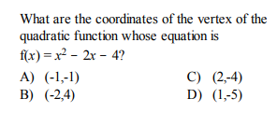



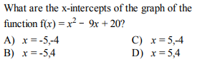



1. 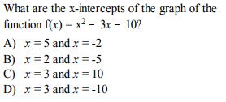

1. 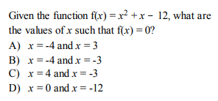
2. 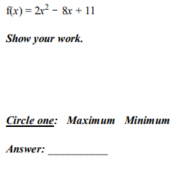 13.

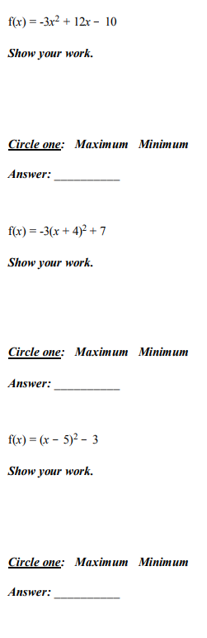







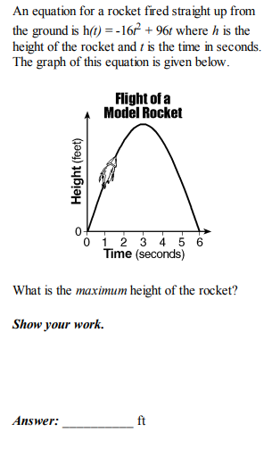



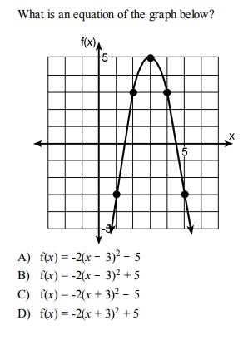

1. 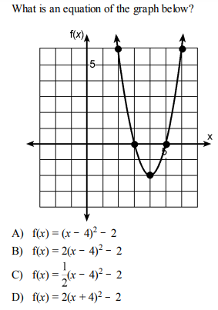

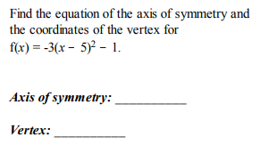



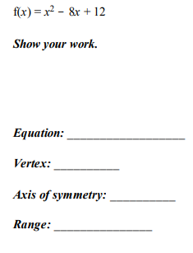

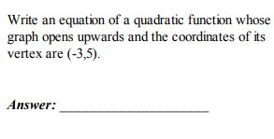



1. 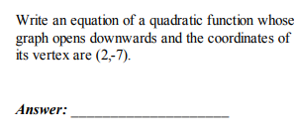

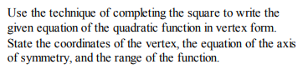

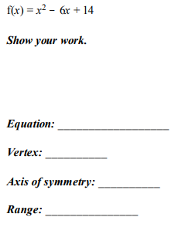



20.

21. Draw the graph of the equations y = x2 – 6x + 3 including all values of x such that [0, 6].

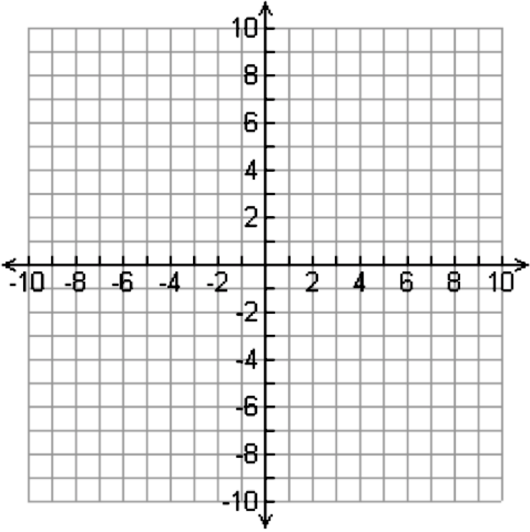

22. Given f (x) = -x2 + 6x – 7

**PART A**

Find an Equation of the axis of Symmetry

Answer: __________________

**PART B**

State the coordinates of the vertex

Answer: __________________

**PART C**

Graph the Parabola



