Name: __________________________________ May 7, 2018

Kobrin/Losquadro Math 8

**The Real Numbers – Homework**

Name all sets to which each number belongs. (Rational, Irrational, Integer, Whole, Counting)

1. -47
2. |-9|
3. 1.5625
4. 0
5. 
6. 
7. 
8. 
9. 
10. 
11. Place the **LETTER** in the smallest set that contains that value
12. 0.5
13. 
14. -|-14|
15. 
16. 

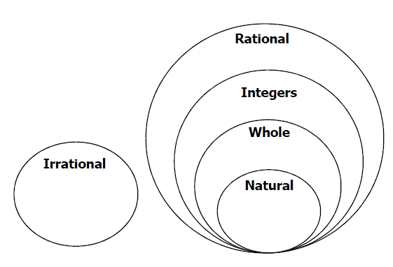

1. 
2. 
3. |13 |
4. 6-2