Name: _____________________________________ April 17, 2017

Teacher: __________________________________ CC Algebra

Unit 10 – Graphing Quadratic Functions

Standard form of a Quadratic Function ________________________________________

Parabola: _______________________________________________________________

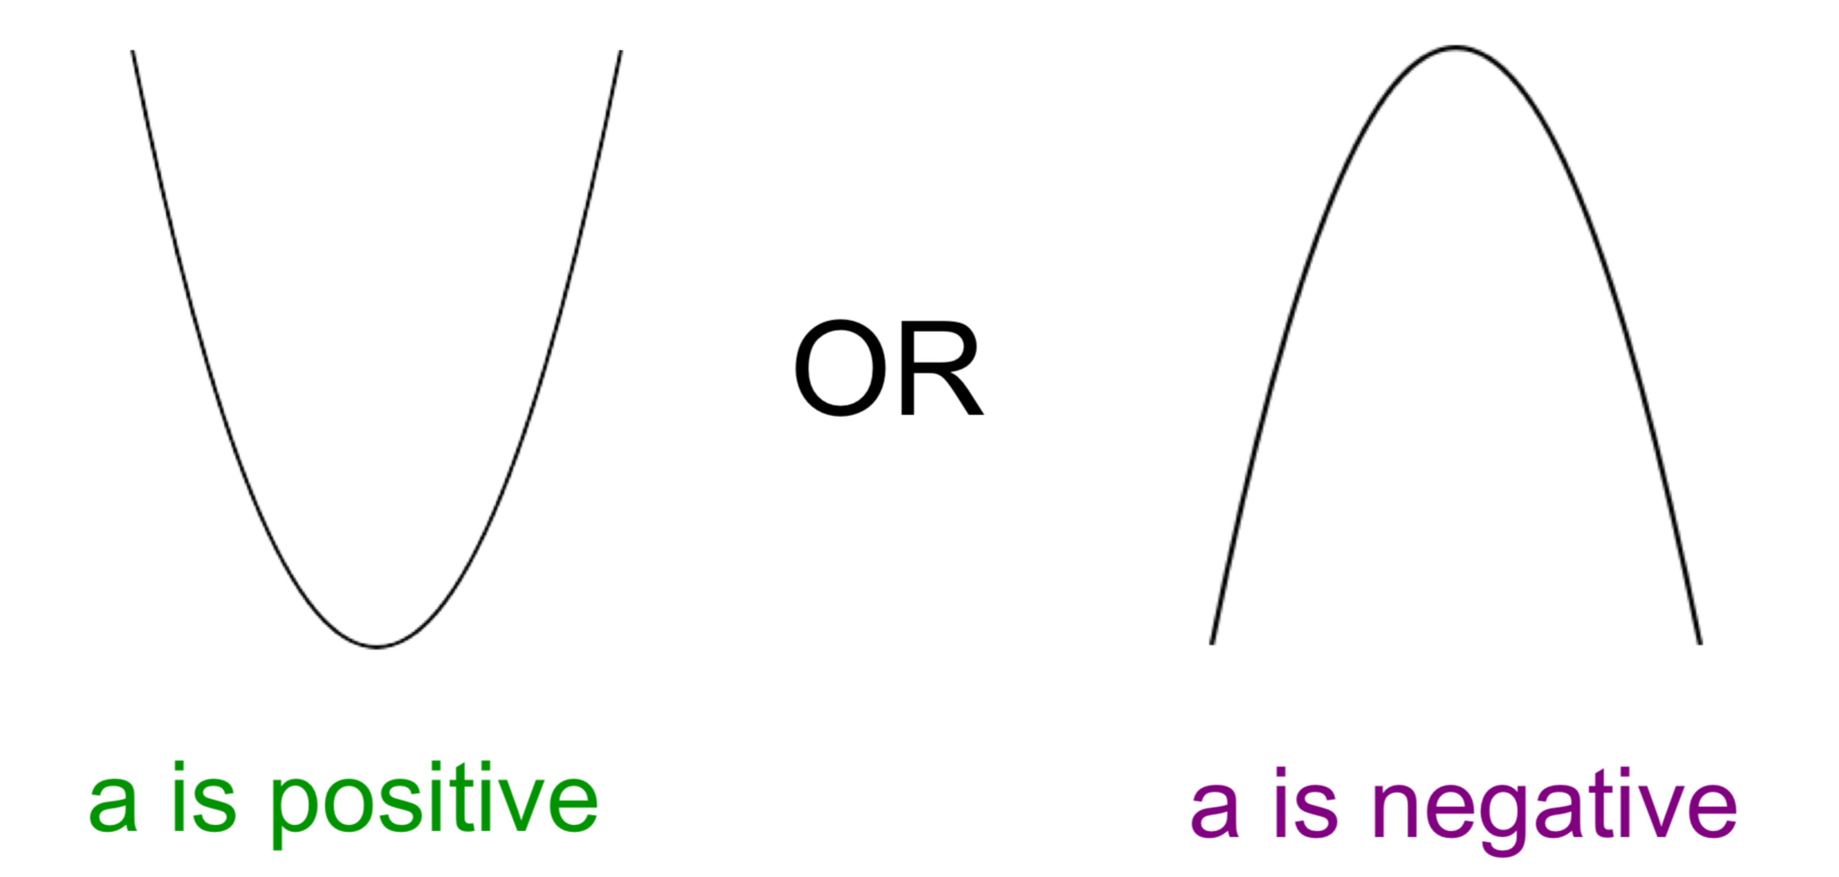

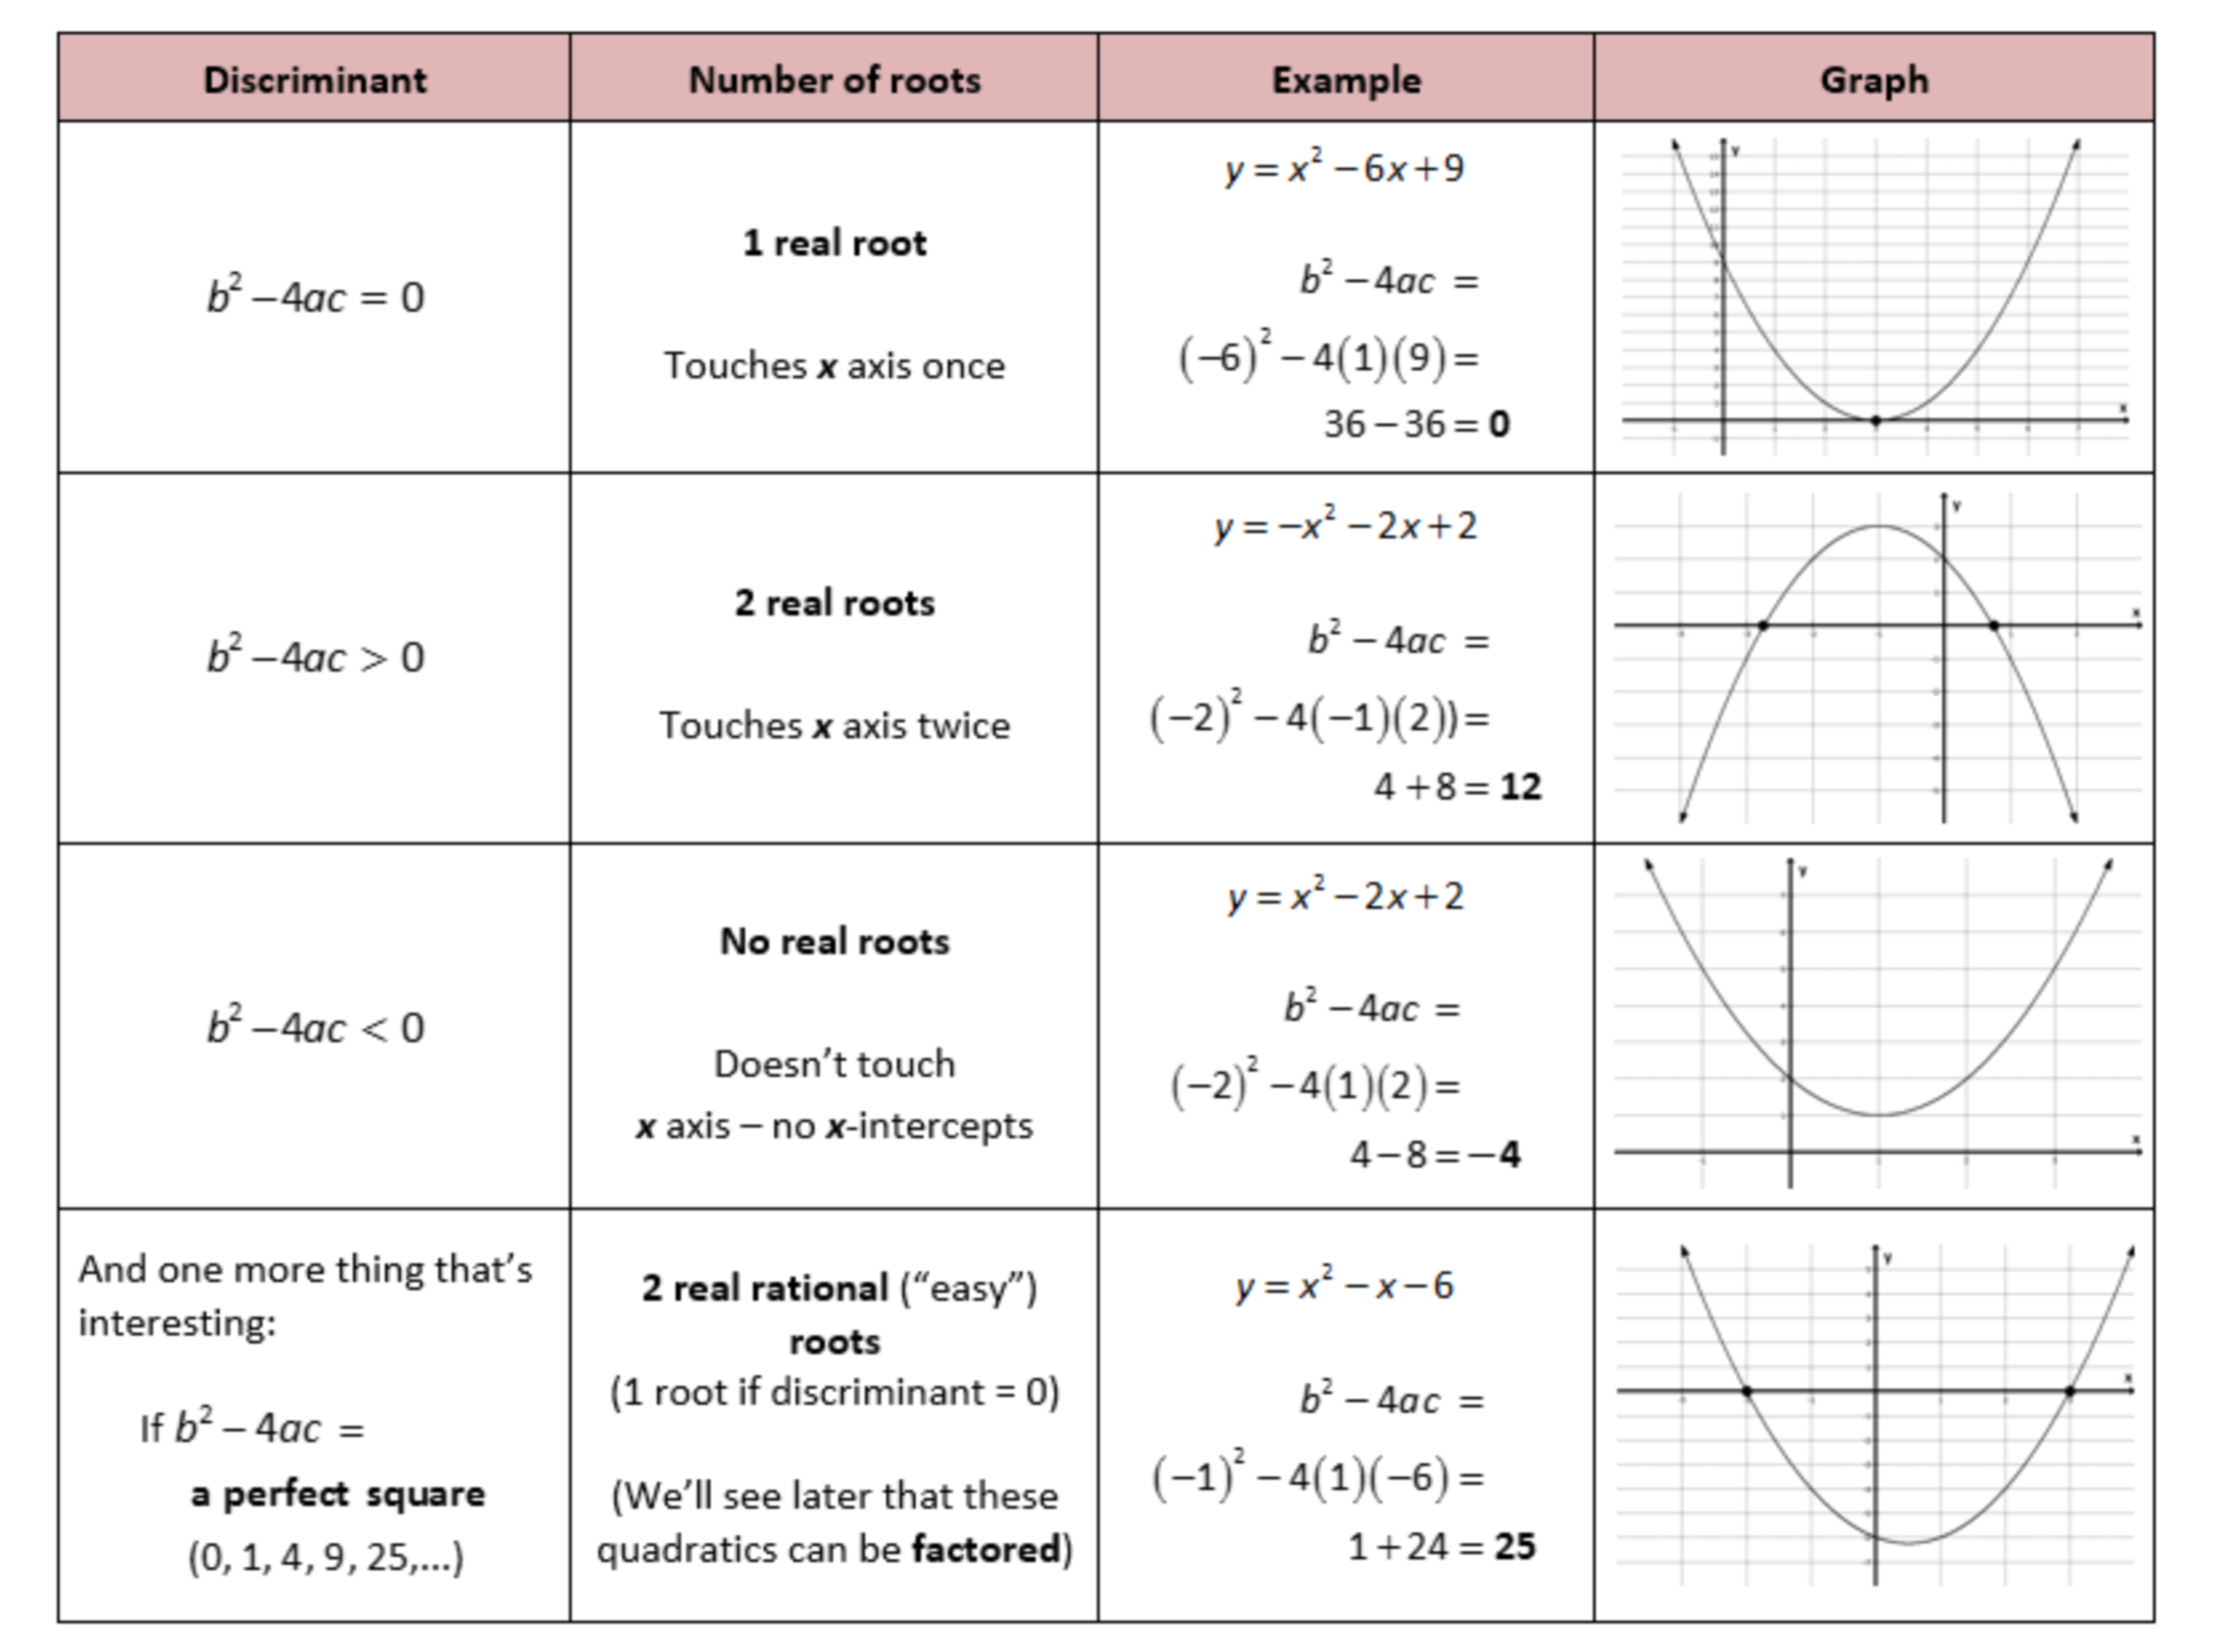
Axis of Symmetry: _________________________________________________________

Vertex: _________________________________________________________________

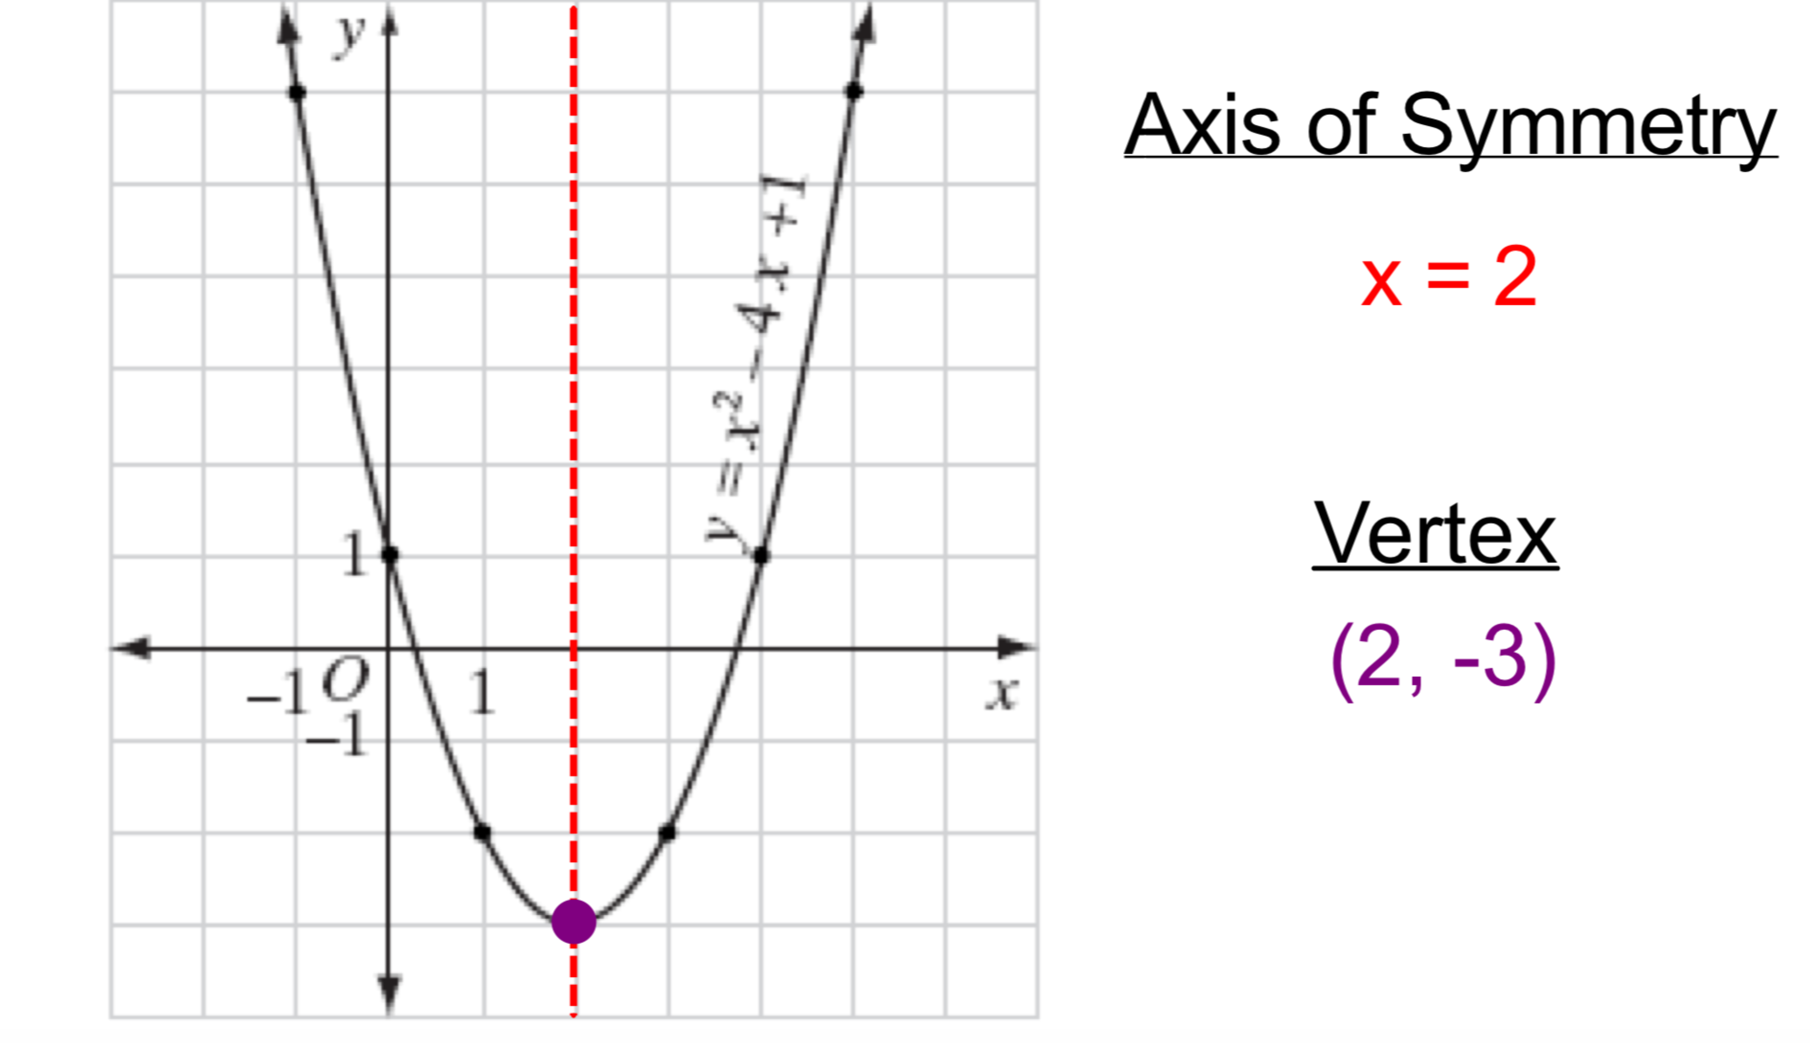

Zeros/Roots/Solutions: _____________________________________________________

________________________________________________________________________

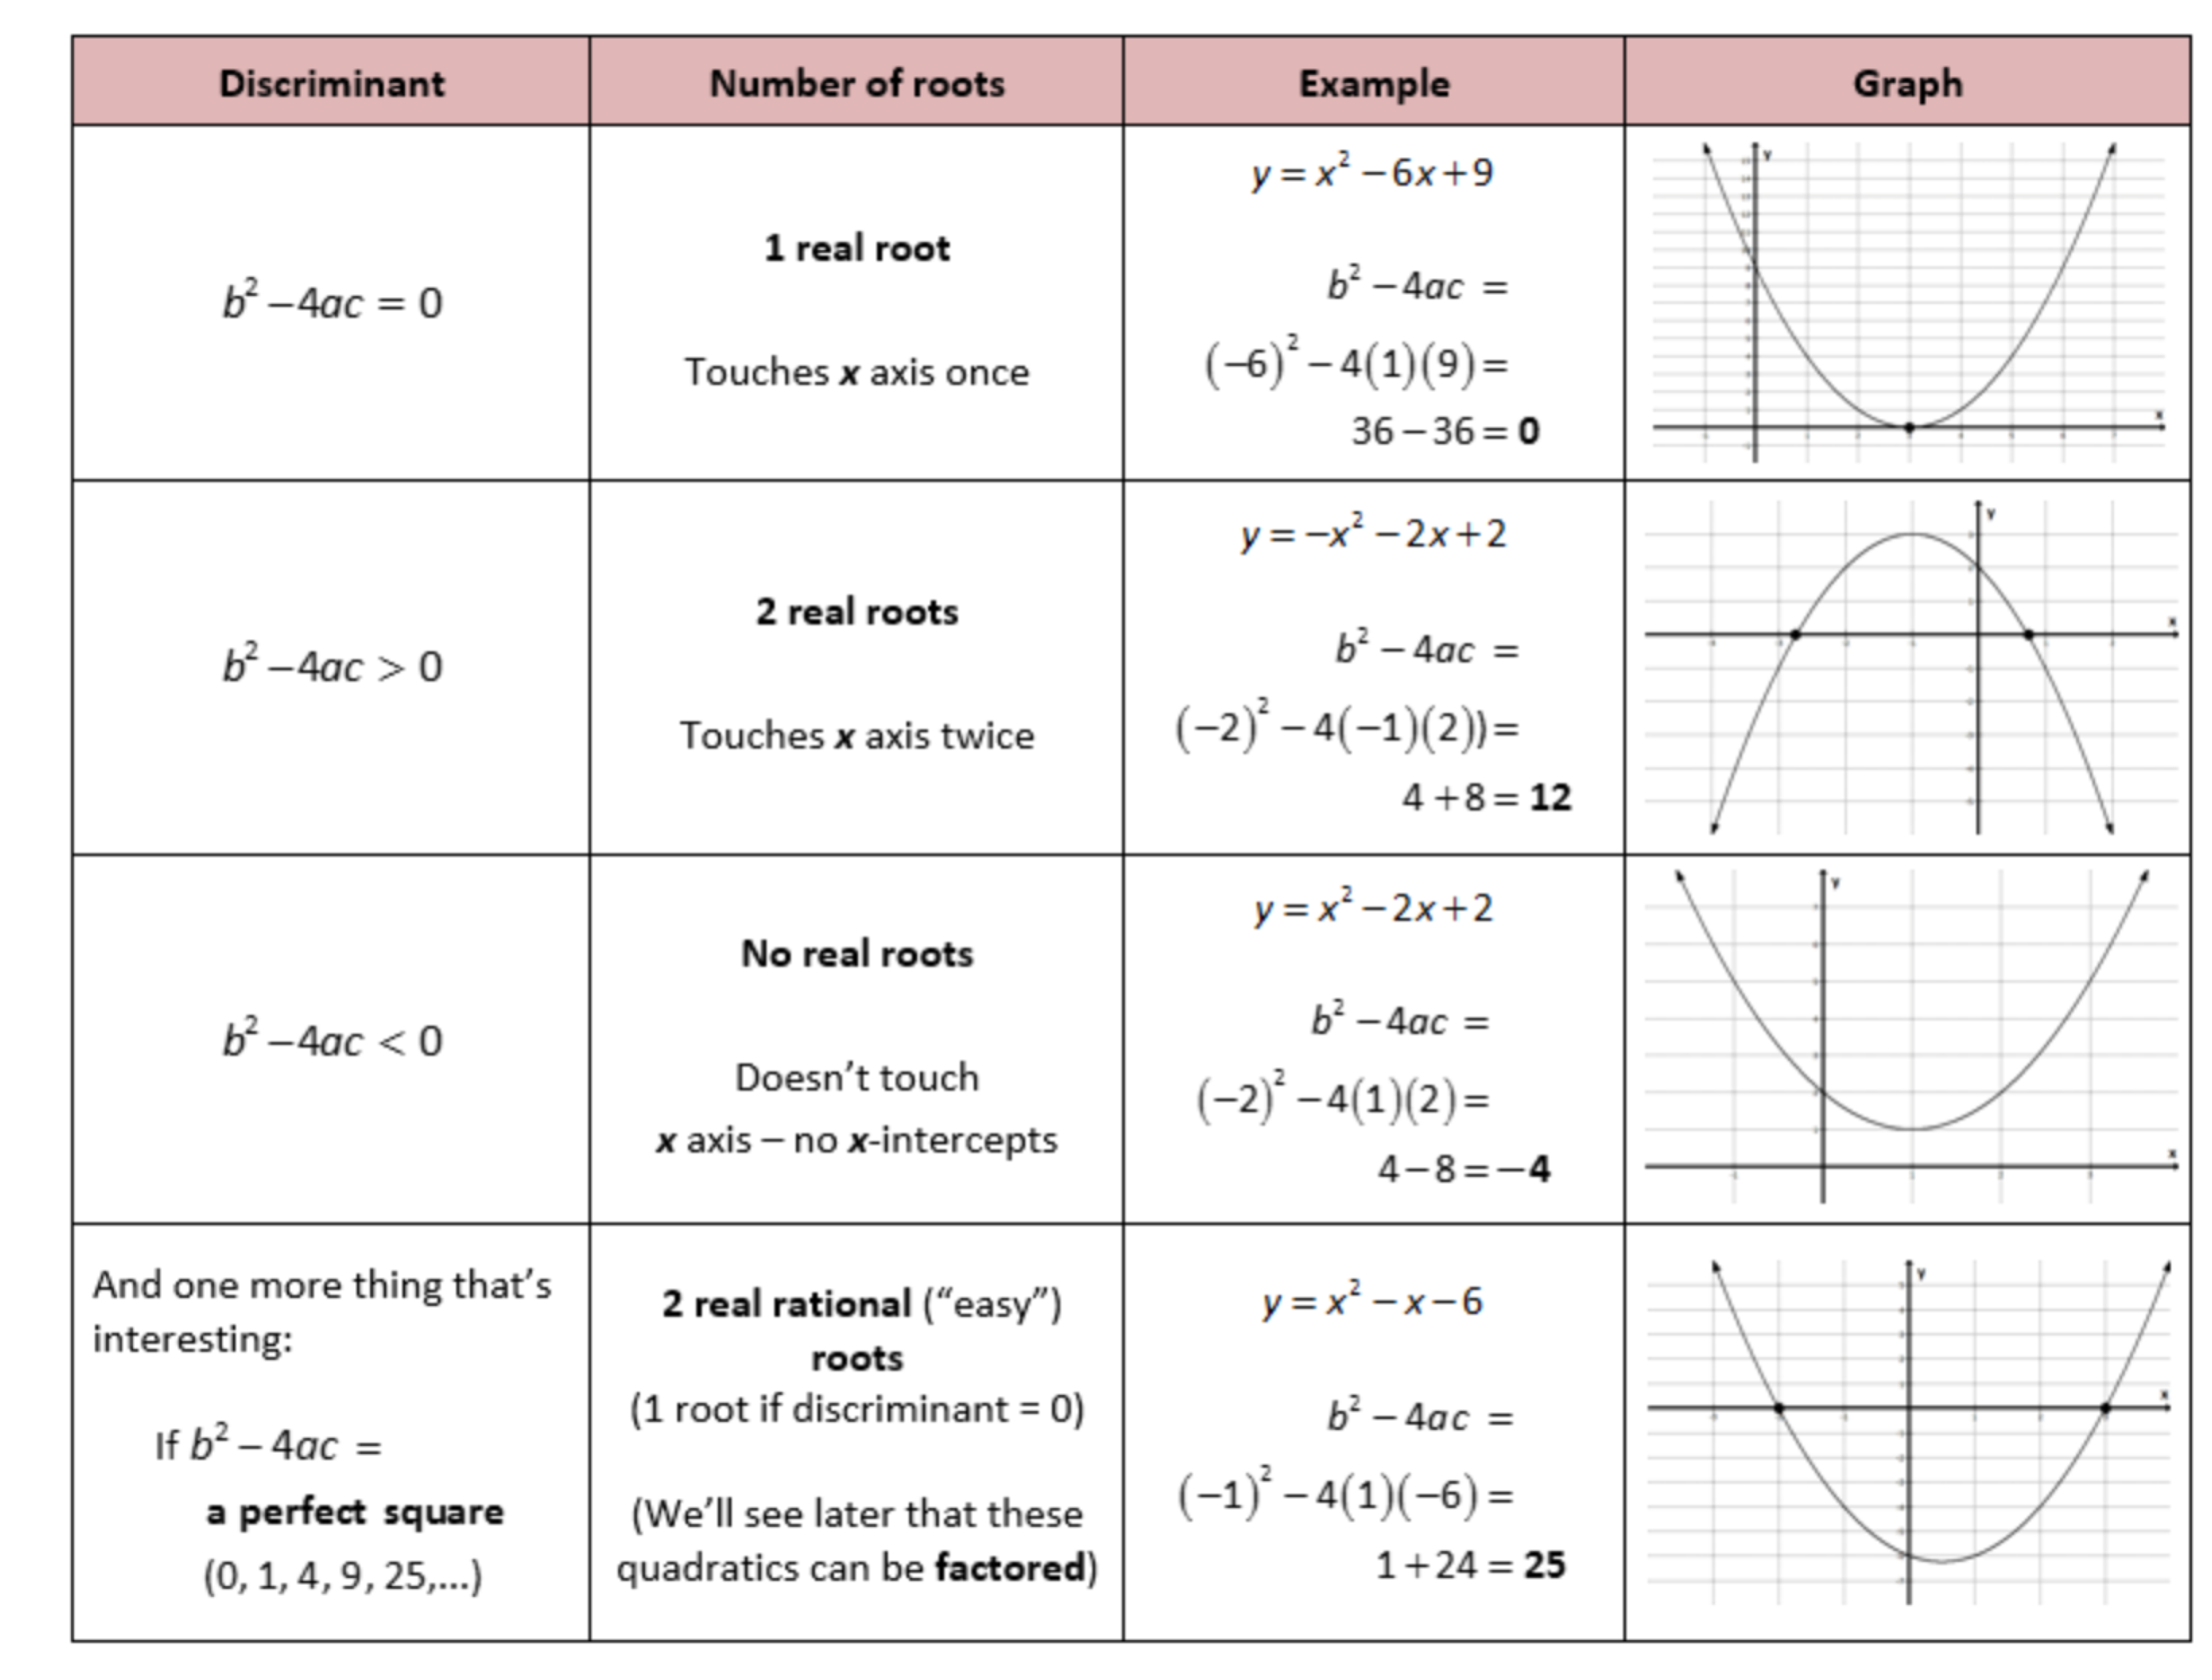

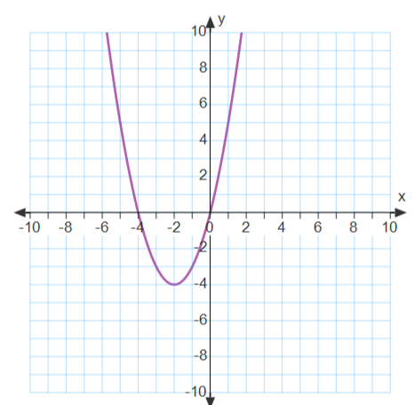
- Using the graph below identify the following. Find the vertex, axis of symmetry and the zeros of the function. Is the vertex a maximum or a minimum?

Vertex: _________________

Axis of Symmetry: ____________________

Zeros of the function: _________________

Min or Max: ________________________

Domain: ___________________________

Range: ____________________________

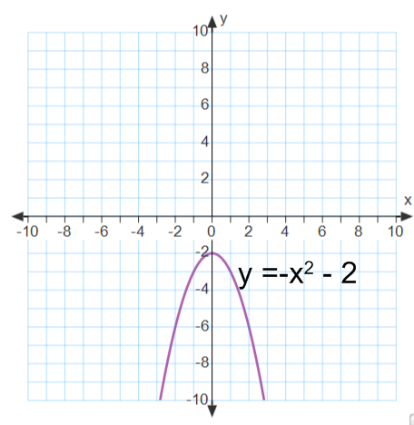
- Using the graph below identify the following. Find the vertex, axis of symmetry and the zeros of the function. Is the vertex a maximum or a minimum?

Vertex: _________________

Axis of Symmetry: ____________________

Zeros of the function: _________________

Min or Max: ________________________

Domain: ___________________________

Range: ____________________________

- Using the graph below identify the following. Find the vertex, axis of symmetry and the zeros of the function. Is the vertex a maximum or a minimum?
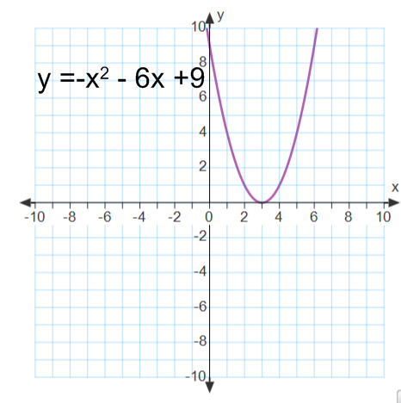
Vertex: _________________

Axis of Symmetry: ____________________

Zeros of the function: _________________

Min or Max: ________________________

Domain: ___________________________

Range: ____________________________

Finding the Axis of Symmetry and Vertex

Axis of Symmetry Formula:

To find the vertex (maximum or minimum) of a parabola:

1) _______________________________________________________________

2) _______________________________________________________________

3) _______________________________________________________________

Find the AOS and Vertex of each

- y = x² - 6x + 8

- f(x) = -x² + 3x

- y = 2x² + 4x + 6

- f(x) = -x² - 4x

