Name: __________________________________ Date: _____________________
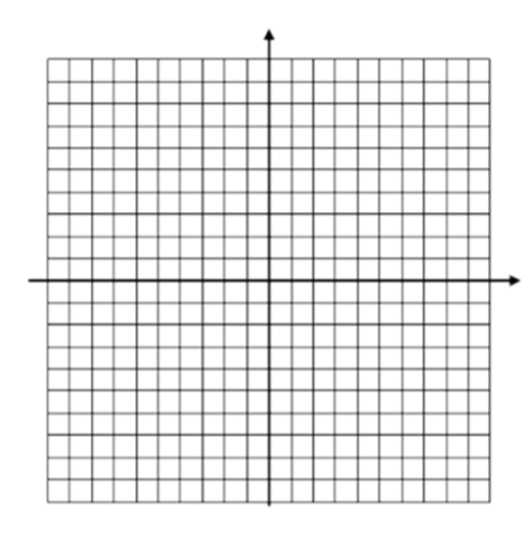
CC Algebra
Quadratic Linear Systems – Solving Graphically – Classwork
- f(x) = x² + 2x + 1
g(x) = 2x + 5

- y = -(x – 2)² + 4
y – 9 = -2x

- $f\left(x\right)=\frac{1}{2}x^{2}-3x+2$
$g\left(x\right)=\frac{3}{2}x-2$

- y = (x - 3)² + 2
2x = 6y

